INDIRA GANDHI NATIONAL OPEN UNIVERSITY

PROJECT PROPOSAL (SYNOPSIS)

MCSP-060

ON

ONLINE BANKING SYSTEM

By

Aman Tiwari (186407279)

UNDER GUIDANCE

OF

Mr. Sabhya Verma

Submitted to the Shyamlal College (0769), IGNOU in

Partial fulfilment of the Requirements for the degree of

Masters

Of

Computer Applications



Indira Gandhi National Open University

Maidan Garhi

New Delhi-110068



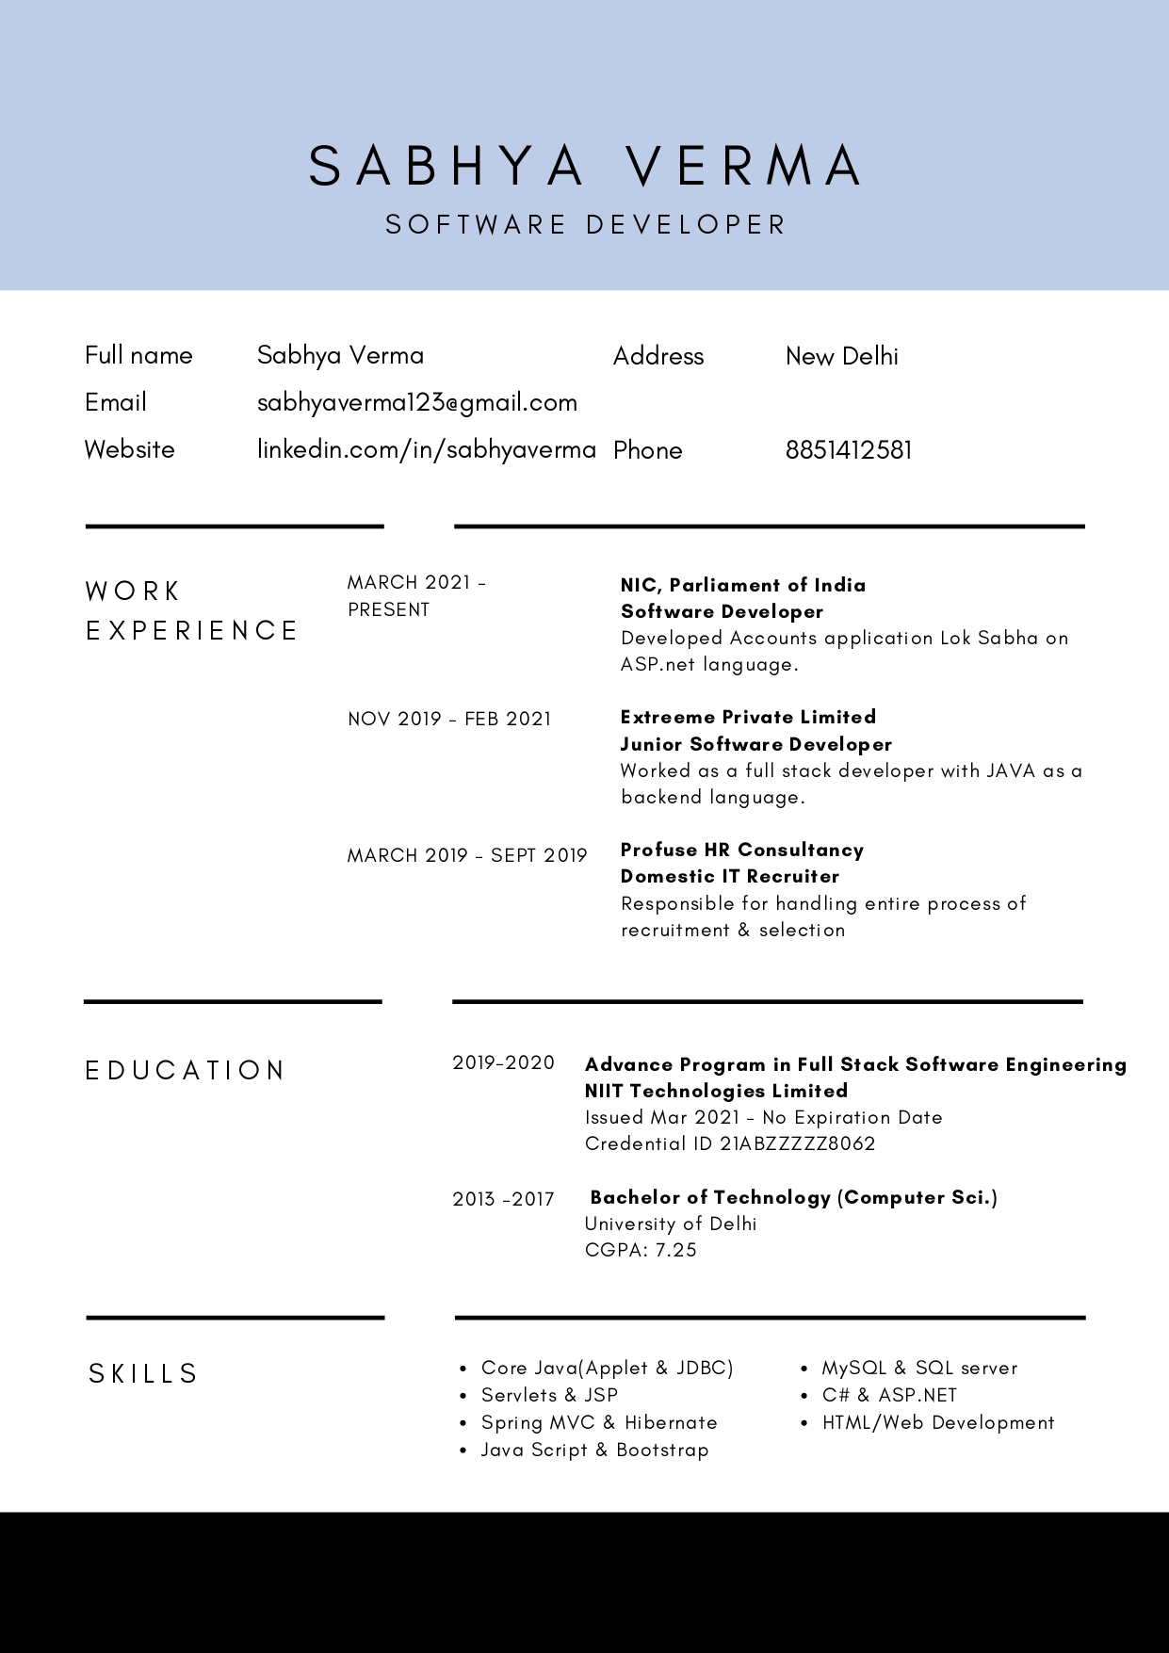

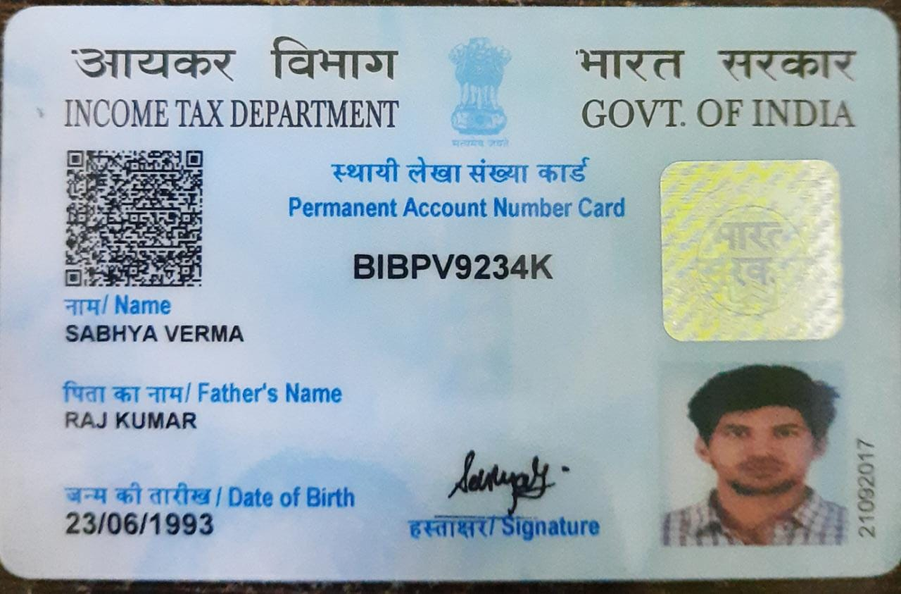

**TITLE OF PROJECT**

**ONLINE BANKING SYSTEM**



# INTRODUCTION OF THE PROJECT

Online banking allows a user to conduct financial transactions via the Internet. Online banking is also known as Internet banking or web banking.

Online banking offers customers almost every service traditionally available through a local branch including deposits, transfers, and online bill payments. Virtually every banking institution has some form of online banking, available both on desktop versions and through mobile apps.

With online banking, consumers aren’t required to visit a bank branch to complete most of their basic banking transactions. They can do all of this at their own convenience, wherever they want—at home, at work, or on the go.

Online banking requires a computer or other device, an Internet connection, and a bank or debit card. In order to access the service, clients need to register for their bank’s online banking service. In order to register, they need to create a password. Once that’s done, they can use the service to do all their banking.

Banking transactions offered online vary by the institution. Most banks generally offer basic services such as transfers and bill payments. Some banks also allow customers to open up new accounts and apply for credit cards through online banking portals. Other functions may include ordering checks, putting stop payments on checks, or reporting a change of address.

Online Banking System is a multifunctional software and hardware that enables bank customers to complete and submit to the Bank for execution documents for payment and other documents, monitor the status of their accounts, and receive a wide range of relevant financial information without directing the bank.

There is no need to bring to the Bank payment and other documents on paper – documents in electronic form have a similar force, and instead of the usual signature on them digital signature is used.

Using the Online Banking System allows managing the financial flows of the customer by accessing the account from home, office or any other workplace and significantly reduces the cost of working time associated with a visit to the Bank.

Using the services offered by online banking is simple and easy. Many find transacting online a lot easier than visiting the branch for the same.

Using Online Banking System, we can

1. Transfer funds in a matter of seconds via secure channel.
2. View all the previous transactions acknowledgements.
3. Add, Remove or Update customer, employee or manager respectively.
4. Track multiple transactions or login time for customer.
5. Register a branch for allowing net banking services for customers.

# OBJECTIVES OF THE PROJECT

The main aim of designing and developing this Online Banking System, JSP primarily based Engineering project is to provide secure and efficient net banking facilities to the banking customers over the internet. Apache Server Pages, MYSQL database used to develop this bank application where all banking customers can login through the secured web page by their account login id and password. Users will have all options and features in that application like get money from other account, money transfer to others, and send cash or money to inter banking as well as other banking customers by simply adding them as payees.

It basically consists of 4 modules: customer, employee, manager and bank admin.

The other 3 modules other than customer module are used to manage the banking system via internet. These modules prove some useful services like:

* + Add, Remove or update customers, employee or manager.
  + Track customer transactions, Freeze/Un-freeze customer account (in employee module).
  + Register a branch for Online Banking to provide services to its customers (in bank admin module).

The Traditional way of maintaining details of a user in a bank was to enter the details and record them. Every time the user needs to perform some transactions he has to go to bank and perform the necessary actions, which may not be so feasible all the time. It may be a hard-hitting task for the users and the bankers too. The project gives real life understanding of Online Banking System and activities performed by various roles in the supply chain. Here, we provide automation for banking system through Internet. Online Banking System project captures activities performed by different roles in real life banking which provides enhanced techniques for maintaining the required information up-to- date, which results in efficiency. The project gives real life understanding of Online Banking System and activities performed by various roles in the supply chain.

The primary aim of this “ONLINE BANKING SYSTEM” is to provide an improved design methodology, which envisages the future expansion, and modification, which is necessary for a core sector like banking. This necessitates the design to be expandable and modifiable and so a modular approach is used in developing the application software. Anybody who is an Account holder in this bank can become a member of ONLINE BANKING SYSTEM. He has to fill a form with his personal details and Account Number.

# TOOLS / ENVIRONMENT USED

We have a wide range of options of languages. From these options we can choose appropriate platform/ tools and languages for development of the project. Some of these are as follows: -

**Project Category: RDBMS project**

**SOFTWARE REQUIREMENTS**

**IDE:** Eclipse oxygen, STS and VS Code.

**Front End:** HTML, CSS, JavaScript, jQuery, Bootstrap and Angular

**Programming Language:** JAVA

**Back End:** Hibernate and Spring boot

**RDBMS:** MySQL 8.10

**Server:** Apache Tomcat 8.0

**Browser:** Chrome, Firefox etc. (latest version)

**Operating System:** Windows 7 and above, Linux and Mac

#### HARDWARE REQUIREMENTS:

**Processor** : Intel Pentium, Core duo or more

**Ram** : 2GB or more

**Cache** : 512 KB

**Hard-disk** : 50 GB hard disk recommended Monitor, Keyboard & mouse.

# ANALYSIS DOCUMENT

## ANALYSYS STUDY:

Systems analysis the process of observing systems for troubleshooting or development purposes. It is applied to information technology, where computer- based systems require defined analysis according to their makeup and design.

An Online Banking System is almost a necessity in day-to-day services if all parts of operations are consolidated within one software system so that:

* + Manual files are not needed
  + Communication between different banks and their branches is facilitated through an integrated database
  + Functionality is improved
  + Control is facilitated
  + Security is enhanced

Analysis study is presented in the form of Software Requirement Specification. Review of SRS is conducted to determine the suitability and the adequacy of the software requirement. The review addresses the following questions/issues:

* Are the requirements appropriate to the user needs or project objectives?
* Are the requirements complete?
* Are the requirements defined unambiguously?
* Are the requirements self-consistent?
* Is every requirement testable?

## USER REQUIREMENTS:

One must know what the problem is before it can be solved. General approaches for determining user requirements are:

* + Preliminary investigation – asking general questions
  + Analysis of existing System – getting information from existing System
  1. **PRELIMINARY INVESTIGATION:**

For this, the need arises to understand the viewpoint of two important entities:

* + - Top management
    - Users

In order to gather pertinent information, I interviewed the Top Management (employees and manager) and asked the following questions:

* How the present Banking System works and what are its drawbacks?
* What is their vision about the new System and what new facilities they want from the new System?
* How will data flow in the System?
* Who will be authenticated to access data and his/her access rights?
* Will users be accustomed to the new system?

To find more about present System’s working mechanism such as the ways of getting inputs and providing outputs, I interviewed the Current Users of the System or customers by asking following question:

* Are they comfortable with the present System and flaws exist in it?
* Do they feel the necessity of new System?
* What will be their requirements from new System?
* Are they satisfied with their services in present System?
* Will they be comfortable to use the new System?

After carrying out these interviews, I drew conclusion about the Top Management’s requirements and Users are in support of the new System.

### ANALYSIS OF THE EXSISTING SYSTEM:

The existing version of the software was created in JSP, Servlet and MySQL.

This version will also have the same software and hardware specification as the existing one but certain new features will be introduced such as:

* Transaction Management
* Customer A/c management
* Block and/or resume transaction services
* Manage Employees

### SYSTEM REQUIREMENT:

The techniques which were used to collect data in order to determine the System requirements:

* Reviewing organization documents
* Onsite observations
* Conducting interviews

### REVIEWING ORGANIZATION DOCUMENTS:

I first learnt about how the bank’s involved in the project. I then, got to know how the department works and the employees were directly involved with the application. Customer records and employee records and the documentation of their system helped me to understand the working of the system.

### ONSITE OBSERVATIONS:

It is a process of recognizing and observing people, objects and their occurrence to obtain the information. The major objective of the Onsite Observation is to get as close as possible to real System being studied.

Here, I observed the activities of the System directly. I saw the office environment, workload on the System and on the users. The physical layout of the current System along with the location and movement of staff was analyzed. In this way, the information about the present workflow, objects and people was gathered.

This helped me to understand various procedures & processes, which were to be developed in the new System.

### CONDUCTING INTERVIEWES:

Written documents and onsite observation just tell that how the System should operate. They do not include enough details to allow a decision to be made about the merits of System proposal and do not present the user views about the current system.

I conducted interviews of the staff, which were directly involved with the application. Also, the regular users of the application were

interviewed. Based on their viewpoints, crystal clear System requirements were jolted down.

### HARDWARE REQUIREMENTS:

**Processor :** Intel or AMD processor with min. 2GHz

**Ram :** 1GB or more

**Cache :** 512 KB

**Hard disk :** 50 GB hard disk recommended

**External Devices :** Monitor, Keyboard, mouse

### COMMUNICATION INTERFACE:

The software may either be installed on a client/server-based setup with a Local Area Network (using the Ethernet interface, one to one connection & TCP/IP protocols) or on a stand-alone machine whereby client and server components reside on the same machine.

A printer shall be used frequently. For this purpose, Dot Matrix printer is the minimum requirement. A line printer should prove to be more efficient.

Authenticated Reports can be generated using a Laser Printer. The software shall be independent of printer type. However, dot matrix printer shall provide reports.

### SOFTWARE REQUIREMENTS:

**Operating System :** Windows 7, 8, 10

### Front End : Angular (HTML, CSS, TS, JQuery, Bootstrap)

**Back End :** MySQL

**Other Technologies:** Spring boot and hibernate

## FEASIBILITY STUDY:

Feasibility Study is the test of the System proposal according to its workability, impact on the current System, ability to meet the needs of the current users and effective use of the resources.

Its main objective is not to solve the problem, but to acquire its scope. It focuses on following:

* + Meet user requirements
  + Best utilization of available resources
  + Develop a cost-effective System
  + Develop a technically feasible System There are three aspects in the feasibility study:
  + **Technical Feasibility**
  + **Economical Feasibility**

### Operational Feasibility

* 1. **TECHNICAL FEASIBILITY**

Issues to be studied are, whether the work for the project will be done with current equipment, existing S/W technology and available personnel? If the new technology is required, then what is the likelihood that it can be developed?

This software is technically feasible. The primary technical requirement includes the availability of Windows 7 or higher version of operating Systems installed in the network. MySQL is also required which was already installed. To develop programs NetBeans 8.1 or higher was required which was also available. Reliability, access power and data security were also available. Thus, through all the ends technical feasibility was met.

### ECONOMICAL FEASIBILITY

Issues to be studied are, whether the new System is cost effective or not? The benefits in the form of reduced cost?

This software is economically feasible. As the hardware was installed from quite beginning, the cost on project of hardware is low. Similarly, the software loaded for this project was used for many other applications. The software cost was under budget. As student trainees were developing the application, there were no major personnel costs associated.

Moreover, the technical requirements were already available so there was no further expenditure for buying software packages.

### OPERATIONAL FEASIBILITY

Issues to be studied are, is there sufficient support for management and users? Is the current method acceptable to users? Will the proposed system cause any harm?

This software is operationally feasible. This application provides the necessary information to the user such as how to enter the information regarding different operations performed on the database. The application was planned in such a way that no prior knowledge was required to go through the various operations. The user just needed to have the basic knowledge of computers.

## SOFTWARE REQUIREMENT SPECIFICATION:

Among all the documents produced during a software development life cycle, writing the SRS document is probably the toughest. One reason behind this difficulty is that the SRS document is expected to cater to the needs of a wide variety of audience. Different people need the SRS document for very different purposes.

Characteristics of a Good SRS Document

Some of the identified desirable qualities of the SRS documents are following: -

**Concise:** The SRS document should be concise and at the same time unambiguous.

**Structured:** The SRS document should be well structured.

**Black-box view:** It should only specify what the System should do and refrain from stating how to do.

**Conceptual integrity:** The SRS document should exhibit conceptual integrity so that the reader can easily understand the contents.

**Response to undesired events:** The document should characterize acceptable responses to undesired events.

**Verifiable:** All requirements of the System as documented in SRS document should be verifiable. This means that it should be possible to determine whether or not requirements have been met in an implementation.

The SRS of Online Banking System is as follows:

* 1. **INTRODUCTION:**
     1. **PURPOSE:**

The purpose of this document is to present a detailed description of the Online Banking System. It will explain the purpose and features of the system, the interfaces of the system, what the system will do, the constraints under which it must operate and how the system will react to external stimuli. This document is intended for both the stakeholders and the developers of the system and will be liable for the approval or disapproval of the project by the community of the Bank.

### SCOPE:

An online banking system will be applicable everywhere, where banking exists. It will be more efficient and easier way to have a record on systems through which everyone can easily access it according to his rights as compared to the traditional banking system. Every bank will prefer the online banking system instead of the traditional banking system as it contains many useful features and fastest methods for the transactions.

### DEFINITIONS AND ABBREVIATIONS:

Following are the definitions for the jargoned words.

|  |  |
| --- | --- |
| **TERMS** | **DEFINITIONS** |
| MySQL | Structure query language for the database purposes. Used to  define procedures to store and retrieve data. |
| Customer | A lay person who needs the system to do his task efficiently and effectively. An account holder or a bank’s website  visitor. |
| Database | Collection of all the information monitored by this system. |
| Hibernate | An ORM (Object Relational mapping Tool) used to map  objects of a class in Java to the relational table. |
| Employee /  Account teller | Bank staff that provides information about an account to the user who visits the bank branch physically. |
| Computer Systems | Computers, which will be used as clients to access the server  database according to its right. |
| Visitors | Anyone visiting the site. |
| Bank Features | All the benefits and characteristics that bank provide. These  features will be explained to the new comer visiting the website without an account. |
| Administrator  / Manager | A person that will be responsible for the addition and deletion of the staff members from the general database of the system. |
| SRS | A document that completely describes all of the functions of a proposed system and the constraints under which it must  operate. For example, this document. |
| Stake Holder | Any person with an interest in the project who is not a  developer. |

### REFERENCES:

This web application has been prepared on the basis of discussion with Team members, faculty members and also taken information from following books & website.

* + - * Websites:
        + [www.google.co.in](http://www.google.co.in/)
        + [www.wikipedia.org](http://www.wikipedia.org/)
        + [www.youtube.com](http://www.youtube.com/)
      * Books:
        + Fundamental of Software Engineering by Rajiv Mall.
        + Software Engineering: A practitioner’s approach Ed. by Pressman, Roger.
        + Software Engineering Seventh Edition Ian Somerville.
        + Software Engineering Ed.2 by Jalota & Pankaj.
        + Schaum’s Series, “Software Engineering”.

### GENERAL DESCRIPTION:

* + 1. **PRODUCT PERSPECTIVE:**

In traditional system, customer should have to visit the Bank branch physically for the transactions or some other tasks. It wastes time.

After implementing the online banking system customer will be able to connect to his account through the internet connection. Time usage will be minimized, task will be done fast instead of waiting someone other to complete his task.

### FUNCTIONALITIES:

1. **Online balance check and transaction information:**

Customer will be able to check his balance online while sitting at home by accessing the database of the bank using his/her password and account no. allotted him by the bank.

### Save or view past history of transactions:

It will be easy for the customer to view or save his history of all transactions. It will provide him/her the opportunity to maintain his bank balance and needs.

### Balance transfer:

This system will provide a path to the customer of the bank to transfer his balance to other account in easy steps. A small transfer fee will be applicable for this transaction.

### Online record Entry:

Bank staff will input and maintain their record online. It will be easy and efficient for them to serve more and more people in less time.

### Online record search:

Bank staff will easily search a record and update it if needed. Transactions will be faster even physically from the branch because it will be very easy for the bank staff to check the balance of a specific person and update its record if necessary.

### Online Billing Option:

Customers will be able to shop online and pay the bills from their account. A secure way will be provided for the billing. Online shopping will provide them the easiest way to buy and sell their items.

### USER CHARACTERISTICS:

There are various kinds of users for the product. Usually, web products are visited by various users for different reasons.

The users include:

1. Chancellor who will be acting as the controller and he will have all the privileges of administrator.
2. Manager who will handle the operations of the bank of that particular branch.
3. Employee who will handle the requests and queries of the customer.
4. Customer are those who will perform banking.

### GENERAL CONSTRAINTS:

Some general constraints should be defined which will have a great part in the overall succession of the online banking project.

### HARDWARE REQUIREMENTS:

As this system is an online Web-based application so a client server will be the most suitable Organizational style for this system. Computer systems will be needed by each of the actor as well as that user must be connected to the internet.

So, concisely following hardware will be needed.

* 1. Computer systems
  2. Internet availability

### SAFETY AND SECURITY:

This Project must be safe and secure because customers will directly contact their account through the internet. Software will have to identify the valid customer according to his/her bank details and password. So, it is a difficult task to prevent the system by major disasters by preventing the unauthorized access to the system.

### ASSUMPTIONS AND DEPENDECIES:

Following are the assumptions and dependencies which are related to this online banking project.

* This project is a stand-alone project so it will not affect the system where it will be embedded.
* This project is a web-based project while the staff was addict of using traditional methods of data storage and retrieval so they will be trained a bit to jump to it.
* This system will not depend on any other module. It will be a web-based so everyone will independently contact it.
* It is will not affect the environment at all.
* Banks will feel free to adopt it because it will not be so much expensive.
* As this project contains valuable and new features so it will probably remove the previous online banking systems embedded in some banks.

### SPECIFIC REQUIREMENTS:

How the online banking will interact with the environment, what will be the functional and non-functional requirement. These all the steps should be defined here for providing a powerful base to the design phase. The design of the project will completely depend on the functional and non- functional requirements. So, these should be defined clearly and accurately for the effectiveness.

### FUNCTIONAL REQUIREMENTS:

Following are the services which this system will provide. These are the facilities and functions required by the customer.

1. Online balance check.
2. Online shopping opportunity.
3. Online data entry by the staff.
4. Updating the data.
5. Balance transfer.

### CONTEXT DIAGRAM AND EXTENT LIST:

**BANK WEB SERVER**

MAINTENANCE SYSTEM

SECURITY CONSTRAINTS

ACCOUNT DATABASE

* + - 1. **DATAFLOW DIAGRAM:**

Following is the data flow diagram for the online banking system:

NEW ACCOUNT DETAILS

OPEN ACCOUNT

CUSTOMER DATABASE

BANK MANAGER

CUSTOMER DETAILS

LOGIN CREDENTIALS

ONLINE BANKING SYSTEM

LOGIN

MONEY AMOUNT

WITHDRAW

DEPOSIT

DEPOSIT

AMOUNT REQUEST

DEPOSIT AMOUNT

EMPLOYEE

OTHER BANK

OR BRANCH

MONEY AMOUNT

TRANSFER FUNDS

DEPOSIT AMOUNT

THIRD PARTY

UPDATE BALANCE

UPDATE BALANCE

CUSTOMER

CUSTOMER DASHBOARD

### PROCESS SPECIFICATION:

All the process mentioned in the DFD are described as below.

* + - * + **ONLINE BANKING SYSTEM LOGIN:** Each Customer will have its account Id and password. This page will require both of these attributes for them to access their account.
        + **OPEN ACCOUNT:** A customer can open an account by filling a form in the bank and providing the necessary details. The bank manager will verify the details and allow the customer to open a bank account. The employee will fill the necessary details into the customer database. The customer will only have to register for online banking to avail the services via internet.
        + **CUSTOMER DASHBOARD:** On successful login, the customer will be redirected to the welcome page (or the customer dashboard) which allows customer to use the said services.
        + **WITHDRAW:** Customer can withdraw money from their account from the bank which will automatically get reflected in the database.
        + **DEPOSIT:** Customer can deposit money to their account by depositing the money to the depositor (employee), who will deposit the amount in the respective account.
        + **TRANSFER:** Customer can transfer money to another account via Online Banking.
        + **STAFF LOGIN:** On the Website main page, a staff login link will also be provided. Bank staff will use to input their ID’s and passwords to access their account. Here the

type of staff will also be recognized, if he will be of administration block, he will be sent to the administration module else he will be sent to the record management module.

### EXTERNAL INTERFACE REQUIREMENTS:

These requirements are discussed under the following categorization:

### USER INTERFACE:

Application will be accessed through a Browser Interface. The interface would be viewed best using 1024 x 768 and 800 x 600 pixels resolution setting. The software would be fully compatible with Microsoft Internet Explorer for version 6 and above.

No user would be able to access any part of the application without logging on to the system.

### HARDWARE INTERFACE:

* + - * 1. **SERVER SIDE:**

**Operating System:** Windows 7 or higher.

**Processor:** Pentium 3.0 GHz or higher.

**RAM:** 256 Mb or more.

**Hard Drive:** 10 GB or more.

### CLIENT SIDE:

**Operating System:** Windows 7 or above, MAC or UNIX.

**Processor:** Pentium III or 2.0 GHz or higher.

**RAM:** 256 Mb or more.

### SOFTWARE INTERFACE:

* + - * 1. **CLIENT SIDE:**

HTML, JavaScript, Web Browser, Flash Player, MS Office, Windows XP or higher.

### WEB SERVER:

HTML, MS Office, Windows XP or above.

### COMMUNICATION INTERFACE:

The Customer must connect to the Internet to access the Website:

* Dialup Modem of 52 kbps.
* Broadband Internet.
* Dialup or Broadband Connection with an Internet Provider.

### NON-FUNCTIONAL REQUIREMENTS:

Those requirements which are not the functionalities of a system but are the characteristics of a system are called the non- functionalities. Every software system has some non- functionalities. Just fulfilling the requirements of the user is not a good task, keeping the system accurate, easy to maintain, reliable and secure is also a basic part of software engineering. Online Banking System must have the following non-functional requirements so that I could be said as a complete system.

### PERFORMANCE CONSTRAINTS:

This system must be fit according to the performance wise. It should use less memory and will be easily accessible by

the user. Memory management should be done wisely so that none of the memory part goes wasted.

### HARDWARE LIMITATIONS:

It should be designed in such a way that cheap hardware must be installed to access and use it effectively. It should be platform independent. There should be no hardware limitations. In should be designed to work with the low specification hardware so that it could easily work with the high specification hardware.

### MAINTAINABLE:

Each of the modules should be designed in such a way that a new module can easily be integrated with it.

### RELIABLE:

It should be consistent in its performance and provide secure transactions.

### TESTABLE:

Each module should be made in such a way to make it easy for all kinds of testing and debugging.

## DATA FLOW DIAGRAMS (DFD):

Data Flow Diagramming is a means of representing a System at any level of detail with a graphic network of symbols showing data flows, data stores, data processes, and data sources/destinations.

The purpose of data flow diagrams is to provide a semantic bridge between users and System developers.

The diagrams are:

* + Graphical, eliminating thousands of words;
  + Logical representations, modelling ‘WHAT’ a System does, rather than physical models showing ‘HOW’ it does it;
  + Hierarchical, showing System s at any level of detail; and Jargon less, allowing user understanding and reviewing.

The goal of data flow diagramming is to have a commonly understood model of a System. The diagrams are the basis of structured System’s analysis. Data flow diagrams are supported by other techniques of structured System s analysis such as data structure diagrams, data dictionaries, and procedure-representing techniques such as decision tables, decision trees, and structured English.

The objective of Data flow diagrams is avoiding the cost of user/developer misunderstanding of a System, resulting in a need to redo System’s or in not using the System.

Having to start documentation from scratch when the physical System changes since the logical System, ‘WHAT’ gets done, often remains the same when technology changes.

It helps in removing inefficiencies of System because a System gets "computerized" before it gets "Systematized". Also helps enabling to evaluate System project boundaries or degree of automation, resulting in a project of inappropriate scope.

**DFD SYMBOLS:**

In the DFD, there are four symbols shown in figure below:

* A **Square** defines a source (originator) or destination of data pipeline through which information flows.
* An **Arrow** identifies data flow data in motion. It is a pipeline through which information flows.
* A **Circle** or a "bubble" (some people use an oval bubble) represents a process that transforms incoming data flow into outgoing data flow.
* An **Open rectangle** is a data store - data at rest, or a temporary repository of data.

Basic Symbols and their Meaning

 Process Notations Number DataStore Data Store Notations

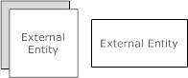 External Entity Notations

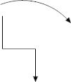Data flow Notations

### 0-(ZERO) LEVEL DFD (CONTEXT LEVEL DFD) FOR ONLINE BANKING SYSTEM

USER INFO

BANKING

USER INFO

SYSTEM

TRANSACTION

REGISTRATION

MONITORING

ONLINE HELP

PASSBOOK ENTRY

USER

USER

**FIRST LEVEL OF DATA-FLOW DIAGRAM FOR SYSTEM LOGIN IN ONLINE BANKING SYSTEM OF ADMIN LOGIN DETAILS**

LOG IN

**SYSTEM ADMINISTRATOR**

ENTER USERNAME OR PASSWORD

USERNAME/PASSWORD VERIFICATION

EXIT FROM SYSTEM

VERIFICATION FAIL

VERIFY USERNAME AND PASSWORD

VERIFICATION SUCCESS

ONLINE BANKING SYSTEM

### FIRST LEVEL OF DATA-FLOW DIAGRAM FOR CUSTOMER TRANSACTION IN ONLINE BANKING SYSTEM

LOGIN



CHECK ACCOUNT

ACCEPT INTO

PROMPTS AMOUNT

AMOUNTS INTO

UPDATES DATABASE

REJECT INFO

**BANK SERVER DATABASE**

**BANK SERVER DATABASE**

ACCOUNT DETAILS

MONEY

PRINT DETAILS

**SECOND LEVEL DATA-FLOW-DIAGRAM OF ONLINE BANKING SYSTEM**

ADMIN

FORGOT

PASSWORD

SEND EMAIL TO

USER

LOGIN TO

SYSTEM

MANAGE

ROLES OF ACCESS

MANAGE ACCOUNT DETAILS

MANAGE BALANCE DETAILS

CHECK

CREDENTIALS

**MANAGE**

**MODULES**

MANAGE BRANCH DETAILS

MANAGE REPORT

MANAGE USER PERMISSION

MANAGE LOGIN ACTIVITY

MANAGE USER ROLE

MANAGE SYSTEM ADMIN

MANAGE TRANSACTION DETAILS

MANAGE BANK DETAILS

## ER-DIAGRAM:

E-R (Entity – Relationship) Model Diagram.

In software engineering an entity relationship model diagram (E-R model diagram) is a data model for describing a database in an abstract way. An ER diagram shows the relationship among entity sets. An entity set is a group of similar entities and these entities can have attributes. In terms of DBMS, an entity is a table or attribute of a table in database, so by showing relationship among tables and their attributes, ER diagram shows the complete logical structure of a database. It is widely used to develop an initial design of a database. It describes data as a collection of entities, relationship and attributes.

E-R Diagram are composed of:

1. **ENTITY:**

An entity is an object or component of data. An entity is represented as rectangle in an ER diagram.

**ENTITY**

### ATTRIBUTE:

An attribute describes the property of an entity. An attribute is represented as Oval in an ER diagram. There are four types of attributes:

* + Key attribute

**ATTRIBUTE**

* + Composite attribute
  + Multivalued attribute
  + Derived attribute

### RELATIONSHIP:

A relationship is represented by diamond shape in ER diagram, it shows the relationship among entities. There are four types of relationships:

* + One to One

IS-A / HAS-A

* + One to Many
  + Many to One
  + Many to Many

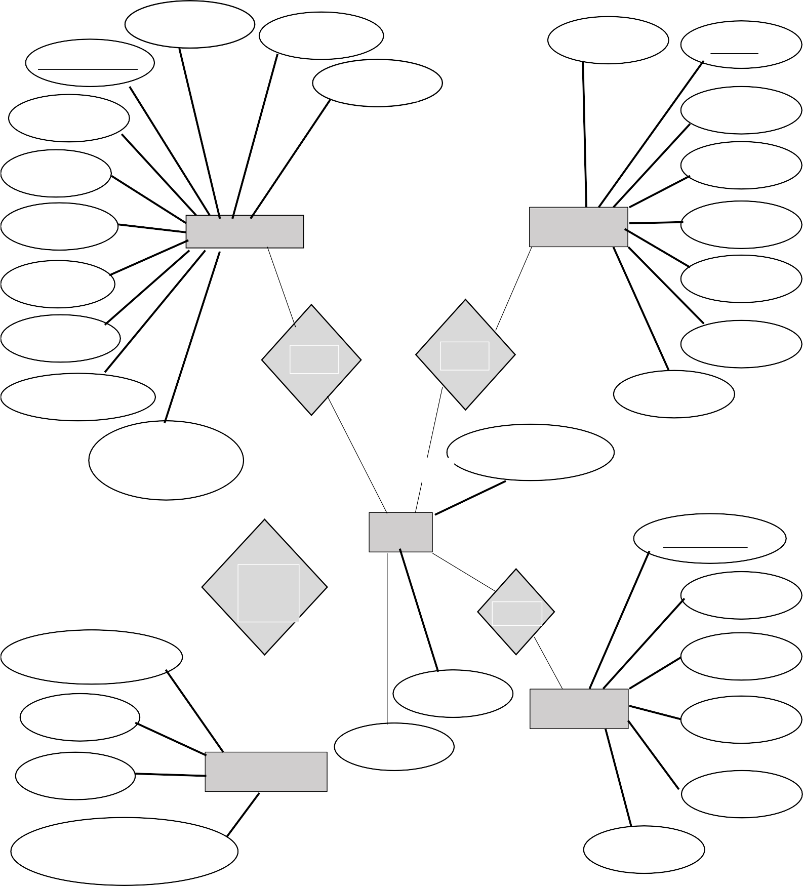

ACCOUNT_NUM

USERNAME

IFSC_CODE

➢

NAME

EMP_ID

PASSWORD

NAME AADHAAR

EMAIL

BALANCE

➢

CUSTOMER

M

EMPLOYEE

M

MOBILE EMAIL

PASSWORD IFSC_CODE

MOBILE

1

HAS HAS

SALARY

TYPE_OF_ACCOUN

USERNAME

NETBANKING_ ALLOWED

1 BRANCH_NAME 1

Manager_id

CAN MAKE

BANK

1

HAS

NAME

TRANSACTION NO

DEBIT

CREDIT

M

TRANSACTION

ADDRESS

IFSC_CODE

1

MANAGER

MOBILE

EMAIL

USERNAME

DATE_OF_TRANSACTION

PASSWORD

1. **DATA DICTIONARY:**

A Data Dictionary is a collection of names, definitions, and attributes about data elements that are being used or captured in a database, information system, or part of a research project. It describes the meanings and purposes of data elements within the context of a project, and provides guidance on interpretation, accepted meanings and representation. A Data Dictionary also provides metadata about data elements. The metadata included in a Data Dictionary can assist in defining the scope and characteristics of data elements, as well the rules for their usage and application.

Data Dictionaries are useful for a number of reasons. In short, they:

* + Assist in avoiding data inconsistencies across a project.
  + Help define conventions that are to be used across a project.
  + Provide consistency in the collection and use of data across multiple members of a research team.
  + Make data easier to analyze.
  + Enforce the use of Data Standards.

**DESIGN DOCUMENTS**

## MODULARIZATION DETAILS:

The Online Banking System Project consists of 4 functional elements: *Customer transaction module*, *Employee Transaction Module*, *Manager Transaction Module* and *Developer/Administration Module*.

### CUSTOMER MODULE:

This module handles all the customer related functionalities. This is a very important module in the Online Banking System. This module performs the following functions:

* + - Customer Login using username and password.
    - Customer online banking registration, username and password generation.
    - Shows a customized user interface defined as ‘customer dashboard’.
    - Customers can view their details in the dashboard.
    - It provides the functionality of fund transfer which can either be in the same bank or a different bank.
    - View all the past transactions made by the customer.
    - View customer current account balance.

### EMPLOYEE/STAFF MODULE:

This module handles all the customer related queries and requests such as:

* + - Add a new customer
    - Update an existing customer details
    - Remove a customer from the system
    - Block any and all transaction services in case of suspicious activity. Un-blocking functionality is also available.
    - Deposit money to a customer’s account.
    - View all transactions of a customer of their own branch.

### MANAGER MODULE:

This module handles all the staff data. It performs the following functionalities:

* + - Add a new employee
    - Update details of an employee
    - Remove an employee
    - View all the details of each employee

### ADMINISTRATOR MODULE:

This module handles the entire banking system. It performs the following functionalities:

* Register a branch for online banking by adding a new manager to the system.
* Update a property of an existing manager
* View all branches and their managers registered for online banking.

## DATABASE DESIGN:

### Table: CUSTOMER

|  |  |  |  |  |
| --- | --- | --- | --- | --- |
| **Field** | **Type** | **Null** | **Key** | **Default** |
| Account_number | Bigint | No | Primary | Null |
| IFSCCode | varchar | Yes |  | null |
| aadhaar | Varchar | yes |  | null |
| Balance | Double | yes |  | null |
| Date_of_creation | Date | yes |  | null |
| Email | Varchar | Yes |  | null |
| Mobile | Varchar | yes |  | null |
| Name | Varchar | yes |  | null |
| netBankingAllowed | varchar | yes |  | null |
| Pan | Varchar | yes |  | null |

|  |  |  |  |  |
| --- | --- | --- | --- | --- |
| Password | Varchar | yes |  | null |
| Type_of_account | Varchar | yes |  | null |
| Username | Varchar | yes |  | null |
| IFSCcode_id | Int | yes | foreign | null |

**Table: BANK**

|  |  |  |  |  |
| --- | --- | --- | --- | --- |
| **Field** | **Type** | **Null** | **Key** | **Default** |
| Id | Int | No | Primary | Null |
| Address | Varchar | Yes |  | Null |
| Branch_name | Varchar | Yes |  | Null |
| IFSC | Varchar | Yes |  | Null |
| Employee_emp_id | Bigint | Yes | Foreign | Null |
| Customer_account_number | Bigint | Yes | Foreign | Null |

### Table: EMPLOYEE

|  |  |  |  |  |
| --- | --- | --- | --- | --- |
| **Field** | **Type** | **Null** | **Key** | **Default** |
| Employee_id | Bigint | No | Primary | Null |
| IFSCcode | Varchar | Yes |  | Null |
| Aadhaar | Varchar | Yes |  | Null |
| Email | Varchar | Yes |  | Null |
| Mobile | Bigint | Yes |  | Null |
| Name | Varchar | Yes |  | Null |
| Salary | Double | Yes |  | Null |
| username | Varchar | Yes |  | Null |
| Password | Varchar | Yes |  | Null |
| IFSCcode_id | Int | Yes | Foreign | null |

**Table: MANAGER**

|  |  |  |  |  |
| --- | --- | --- | --- | --- |
| **Field** | **Type** | **Null** | **Key** | **Default** |
| Manager_id | Bigint | No | Primary | Null |
| Email | Varchar | Yes |  | Null |
| Mobile | Varchar | Yes |  | Null |
| Name | Varchar | Yes |  | Null |
| Username | Varchar | Yes |  | Null |
| Password | Varchar | Yes |  | Null |
| Id | Int | Yes | Foreign | null |

**Table: TRANSACTIONS**

|  |  |  |  |  |
| --- | --- | --- | --- | --- |
| **Field** | **Type** | **Null** | **Key** | **Default** |
| Transaction_no | Bigint | No | Primary | Null |
| Debit | Varchar | Yes |  | Null |
| Credit | Varchar | Yes |  | Null |
| Date_of_transaction | Varchar | Yes |  | Null |

## PROCEDURAL DESIGN:

Procedural design is often classified as a computational approach relying upon a set of instructions that, when used in a particular sequence, are the generators of form. While within this frame-work certain methods may be iterative and cyclical, procedural design often denotes the construction, conceptually, of a linear solver. The work documented in this section, though, shows a significant evolution of this approach. Intelligent systems are formed in which computation is given the freedom to absorb, interpret, and respond within the sequential set of procedures, thus shifting from linear logics to networked ones. This is addressed through

papers that discuss the language through which such processes are enacted and explore the emergence of a built architecture through dynamic logics of design computation.

Traditionally, procedural design has offered means of testing the relationships of parameters, but the work shown in this section demonstrates an evolution of this approach. Procedural processes become an active agent for resolving the relation-ships of systems.

This design starts right after the data and its structure has been established.

Procedural details can be represented in different ways:

* **Graphical Design Notation:**

The most widely used notation is the flowchart. Some notation used in flowcharts are:

1. Boxes to indicate processing steps;
2. Diamond to indicate logical conditions;
3. Arrows to indicate flow of control;
4. Two boxes connected by a line of control will indicate a Sequence.

### Tabular Design Notation:

Decision tables provide a notation that translates actions and conditions (described in a processing narrative) into a tabular form.

1. The upper left-hand section contains a list of all conditions.
2. The lower left-hand section lists all actions that are possible based on the conditions.
3. The right-hand sections form a matrix that indicates condition combinations and the corresponding actions that will occur for a specific combination.

### Program Design Language (PDL):

Program Design Language (PDL) is also called structured English, or Pseudo code. The main difference between PDL and its nearest neighbour, 4th Generation Languages, is that in PDL, the use of narrative text (e.g., English) I s embedded directly within PDL statements. PDL have the following characteristics:

1. A fixed syntax of keywords that provide for all structured constructs, data declaration, and modularity characteristics.
2. A free syntax of natural language that describes processing features.
3. Data declaration facilities that should include both simple (scalar, array) and complex (linked list or tree) data structures.

## USER INTERFACE DESIGN:

With time and creativity, developments have been part of technology. With creativity comes advancement and with advancement comes complexity but we still prefer things to be simple yet advanced. This is when we need to think how to simplify things. We need simplicity in product development and we need simplicity in product use. We need something to fulfil this need. User interface design just fits in there. It helps developer/designer to create end product in logical and sequential way. User Interface (UI) design has four main elements:

* Usability
* Visualization
* Functionality
* Accessibility

For making user experience enjoyable there are some things that should be considered before jumping into the development process. This will save developer’s time and also designer’s work will go smoothly. The end result will be usable.

While creating the UI of the Online Banking System, the points were kept in mind:

* **CONSISTENCY:**

Users do not like inconsistent pages. Inconsistency makes things complex while consistency provides clarity. Some basic elements of an application user interface that designer should be consistent with are colour scheme, style, borders, type and fonts, size, background images and effects. It helps users remember one’s design. It adds the right feel for users to be there. Throw users different typography in different pages, different sizes and colours without any meaning or reason behind, they are going to get bored and never return to that site again. Consistency can be achieved by a thoughtful design, potential end users research, using master pages and CSS while developing.

* **RESPONSIVENESS:**

The basic idea of the site being responsive is the site responding to users actions. It also means giving the users the feeling that we are listening to them. Nobody likes to talk to a tree. If the page is taking time to load, one can provide some visual graphical representation or any plain text that suggests that the page is loading or telling them the progress status. Use of heavy graphics can add to the response time of a web page. Therefore, minimizing sizes and use of them as little as possible can help minimize the problem. Using alternatives also help, for example, if an image has not loaded for some reason, alternative text stating what image it is, helps the user to at least understand the idea behind the problem.

* **FAMILY METAPHORS:**

Use of terms already familiar to users from other existing internet sites helps them to familiarize with the website faster. For example, in general sites, words such as share, signup and login are very common, so using them to the newly designed pages will help users to skip understanding these parts of the site which will help in minimizing the learning process. One should always be sure to use metaphors taking cultural boundaries into account. It is easy to get people offended when cultural differences are not well under-stood. Background research and consult with respective representative should be made to avoid possible tension and misunderstandings.

* **STREAMLINING THE EXPERIENCE:**

Streamlining the experience is about improving the navigation of a site, making navigation more consistent and enjoyable. Use of unnecessary pages or navigation paths should be avoided. The site should be kept simple and navigation clear. Top level navigation flow should be predefined. Every page could for instance have a banner that on clicking takes the user to the first page or commonly known as home page. Also, all pages should contain link to organization’s contact information, for example, bank’s customer care information.

Code

# TESTING

Software Testing is the process of executing software in a controlled manner, in order to answer the question - Does the software behave as specified?

Software testing is often used in association with the term’s verification and validation. Validation is the checking or testing of items, includes software, for conformance and consistency with an associated specification. Software testing is just one kind of verification, which also uses techniques such as reviews, analysis, inspections, and walkthroughs. Validation is the process of checking that what has been specified is what the user actually wanted.

Validation : Are we doing the right job? Verification : Are we doing the job right?

Software testing should not be confused with debugging. Debugging is the process of analyzing and localizing bugs when software does not behave as expected. Although the identification of some bugs will be obvious from playing with the software, a methodical approach to software testing is a much more thorough means for identifying bugs. Debugging is therefore an activity which supports testing, but cannot replace testing.

Other activities which are often associated with software testing are static analysis and dynamic analysis. Static analysis investigates the source code of software, looking for problems and gathering metrics without actually executing the code. Dynamic analysis

looks at the behavior of software while it is executing, to provide information such as execution traces, timing profiles, and test coverage information.

Testing is a set of activity that can be planned in advanced and conducted Systematically. Testing begins at the module level and work towards the integration of entire computers-based System. Nothing is complete without testing, as its vital success of the System testing objectives, there are several rules that can serve as testing objectives. They are

* Testing is a process of executing a program with the intend of finding an error.
* A good test case is one that has high possibility of finding an undiscovered error.
* A successful test is one that uncovers an undiscovered error.

If a testing is conducted successfully according to the objectives as stated above, it would have uncovered errors in the software also testing demonstrate that the software function appears to be working according to the specification, that performance requirement appears to have been met.

There are three ways to test program.

* For correctness
* For implementation efficiency
* For computational complexity

Test for correctness is supposed to verify that a program does exactly what it was designed to do. This is much more difficult than it may at first appear, especially for large programs.

1. **TEST PLAN:**

A test plan implies a series of desired course of action to be followed in accomplishing various testing methods. The Test Plan acts as a blue print for the action that is to be followed. The software engineers create a computer program, its documentation and related data structures. The software developers are always responsible for testing the individual units of the programs, ensuring that each performs the function for which it was designed. There is an independent test group (ITG) which is to remove the inherent problems associated with letting the builder to test the thing that has been built. The specific objectives of testing should be stated in measurable terms. So that the mean time to failure, the cost to find and fix the defects, remaining defect density or frequency of occurrence and test work-hours per regression test all should be stated within the test plan.

The levels of testing include:

* + Unit Testing
  + Integration Testing
  + System Testing
  + Data Validation Testing
  + Output Testing
  1. **UNIT TESTING:**

Unit testing focuses verification effort on the smallest unit of software design – the software component or module. Using the component level design description as a guide, important control paths are tested to uncover errors within the boundary of the module. The relative complexity of tests and uncovered scope established for unit testing.

The unit testing is white-box oriented, and step can be conducted in parallel for multiple components. The modular interface is tested to ensure that information properly flows into and out of the program unit under test. The local data structure is examined to ensure that data stored temporarily maintains its integrity during all steps in an algorithm’s execution. Boundary conditions are tested to ensure that all statements in a module have been executed at least once. Finally, all error handling paths are tested.

Tests of data flow across a module interface are required before any other test is initiated. If data do not enter and exit properly, all other tests are moot. Selective testing of execution paths is an essential task during the unit test. Good design dictates that error conditions be anticipated and error handling paths set up to reroute or cleanly terminate processing when an error does occur. Boundary testing is the last task of unit testing step. Software often fails at its boundaries.

Unit testing was done in Sell-Soft System by treating each module as separate entity and testing each one of them with a wide spectrum of test inputs. Some flaws in the internal logic of the modules were found and were rectified. Unit testing, also known as component testing, refers to tests that verify the functionality of a specific section of code, usually at the function level. In an object-oriented environment, this is usually at the class level, and the minimal unit tests include the constructors and destructors.

These types of tests are usually written by developers as they work on code (white-box style), to ensure that the specific function is working

as expected. One function might have multiple tests, to catch corner cases or other branches in the code. Unit testing alone cannot verify the functionality of a piece of software, but rather is used to assure that the building blocks the software uses work independently of each other.

Unit testing is a software development process that involves synchronized application of a broad spectrum of defect prevention and detection strategies in order to reduce software development risks, time, and costs. It is performed by the software developer or engineer during the construction phase of the software development lifecycle. Rather than replace traditional QA focuses, it augments it. Unit testing aims to eliminate construction errors before code is promoted to QA; this strategy is intended to increase the quality of the resulting software as well as the efficiency of the overall development and QA process.

Depending on the organization's expectations for software development, unit testing might include static code analysis, data flow analysis metrics analysis, peer code reviews, code coverage analysis and other software verification practices.

### INTEGRATION TESTING:

Integration testing is Systematic technique for constructing the program structure while at the same time conducting tests to uncover errors associated with interfacing. The objective is to take unit tested components and build a program structure that has been dictated by design. The entire program is tested as whole. Correction is difficult because isolation of causes is complicated by vast expanse of entire program. Once these errors are corrected, new ones appear and the process continues in a seemingly endless loop.

After unit testing in Sell-Soft System all the modules were integrated to test for any inconsistencies in the interfaces. Moreover, differences in program structures were removed and a unique program structure was evolved.

### SYSTEM TESTING:

System Testing (ST) is a black box testing technique performed to evaluate the complete system the system's compliance against specified requirements. In System testing, the functionalities of the system are tested from an end-to-end perspective.

System Testing is usually carried out by a team that is independent of the development team in order to measure the quality of the system unbiased. It includes both functional and Non-Functional testing.

### DATA VALIDATION TESTING:

This is the final step in testing. In this the entire System was tested as a whole with all forms, code, modules and class modules. This form of testing is popularly known as Black Box testing.

Black Box testing method focuses on the functional requirements of the software. That is, Black Box testing enables the software engineer to derive sets of input conditions that will fully exercise all functional requirements for a program.

Black Box testing attempts to find errors in the following categories; incorrect or missing functions, interface errors, errors in data structures or external data access, performance errors and initialization errors and termination errors.

### OUTPUT TESTING:

The System considered is tested for user acceptance; here it should satisfy the firm’s need. The software should keep in touch with perspective System; user at the time of developing and making changes whenever required.

This done with respect to the following points:

* + - Input Screen Designs,
    - Output Screen Designs,
    - Online message to guide the user and the like.

The above testing is done taking various kinds of test data. Preparation of test data plays a vital role in the System testing. After preparing the test data, the System under study is tested using that test data. While testing the System by which test data errors are again uncovered and corrected by using above testing steps and corrections are also noted for future use.

## IMPLEMENTATION PROCEDURES:

Implementation of software refers to the final installation of the package in its real environment, to the satisfaction of the intended uses and the operation of the System. In many organizations someone who will not be operating it, will commission the software development project. In the initial stage people doubt about the software but we have to ensure that the resistance does not build up, as one has to make sure that

* The active user must be aware of the benefits of using the new System.
* Their confidence in the software is built up.
* Proper guidance is imparted to the user so that he is comfortable in using the application.

Before going ahead and viewing the System, the user must know that for viewing the result, the server program should be running in the server. If the server object is not up running on the server, the actual process won’t take place.

* 1. **USER TRAINING:**

User training is designed to prepare the user for testing and converting the System. To achieve the objective and benefits expected from computer-based System, it is essential for the people who will be involved to be confident of their role in the new System. As System becomes more complex, the need for training is more important. By user training the user comes to know how to enter data, respond to error messages, interrogate the database and call up routine that will produce reports and perform other necessary functions.

### TRAINING ON THE APPLICATION SOFTWARE:

After providing the necessary basic training on computer awareness the user will have to be trained on the new application software. This will give the underlying philosophy of the use of the new System such as the screen flow, screen design type of help on the screen, type of errors while entering the data, the corresponding validation check at each entry and the ways to correct the date entered. It should then cover information needed by the specific user/ group to use the System or part of the System while imparting the training of the program on the application. This training may be different across different user groups and across different levels of hierarchy.

### OPERATIONAL DOCUMENT:

Once the implementation plan is decided, it is essential that the user of the System is made familiar and comfortable with the environment. Education involves right atmosphere and motivating the user. A documentation providing the whole operations of the System is being developed in such a way that the user can work with it in well consistent way. The System is developed user friendly so that the user can work the System from the tips given in the application itself. Useful tip and guidance are given inside the application itself to help the user. Users have to be made aware that what can be achieved with the new System and how it increases the performance of the System. The user of the System should be given a general idea of the System before he uses the System.

### SYSTEM MAINTENANCE:

Maintenance is the enigma of System development. The maintenance phase of the software cycle is the time in which a software product performs useful work. After a System is successfully implemented, it should be maintained in a proper manner. System maintenance is an important aspect in the software development life cycle. The need for System maintenance is for it to make adaptable to the changes in the System environment. Software maintenance is of course, far more than "Finding Mistakes". Maintenance may be defined by describing four activities that are undertaken after a program is released for use.

# INPUT AND OUTPUT SCREENS

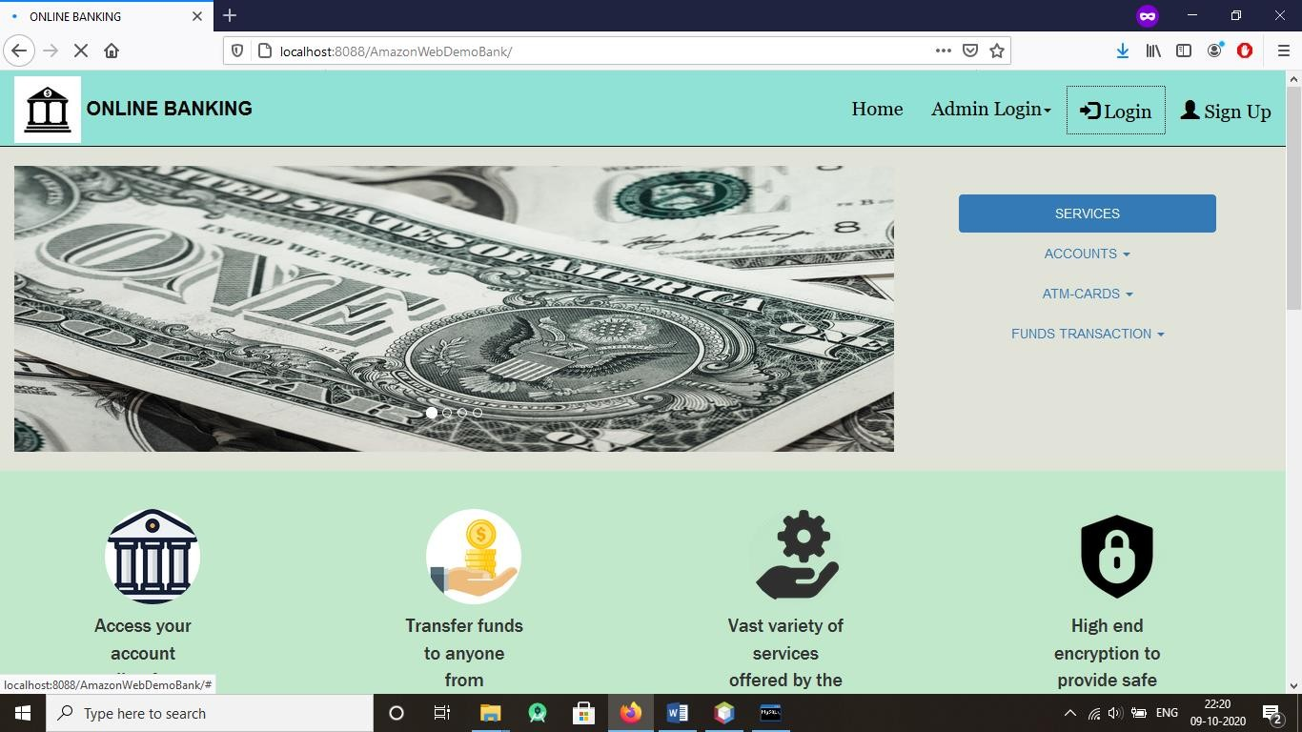

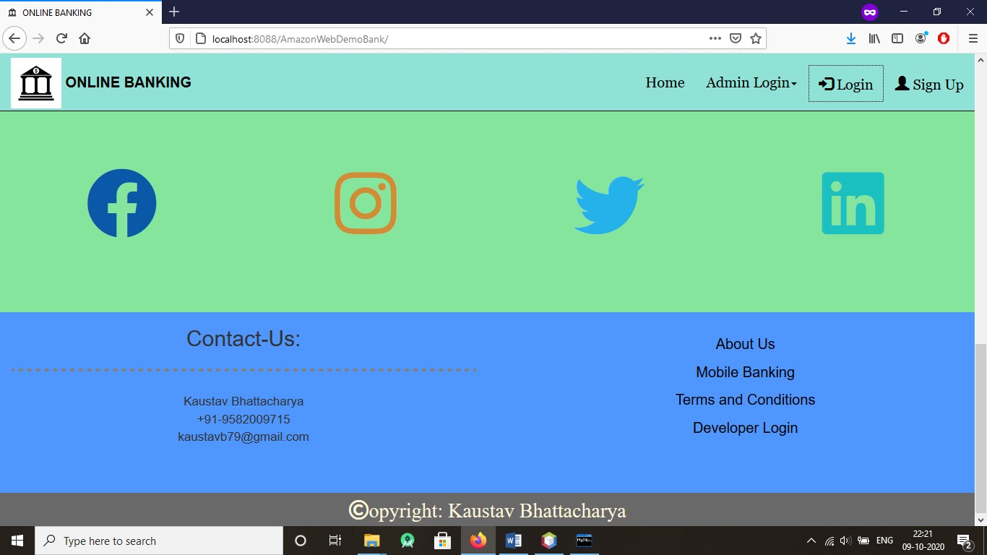

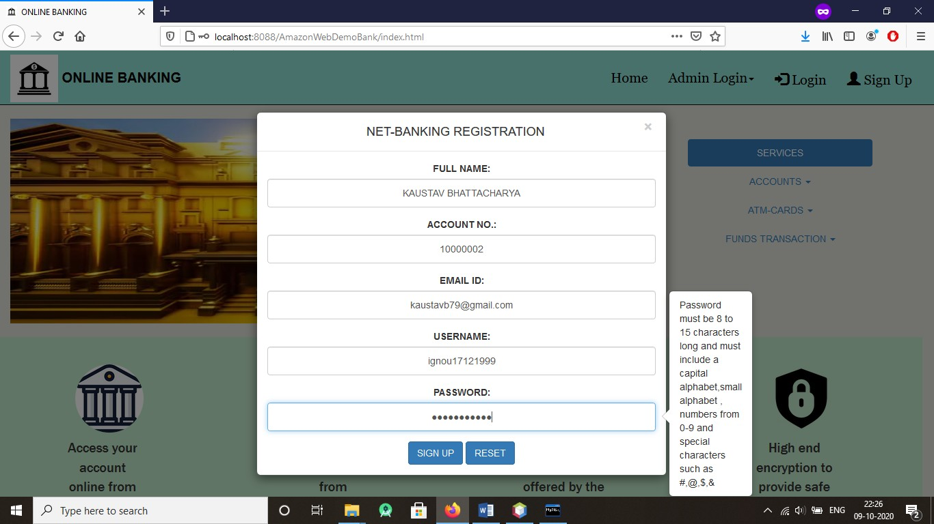

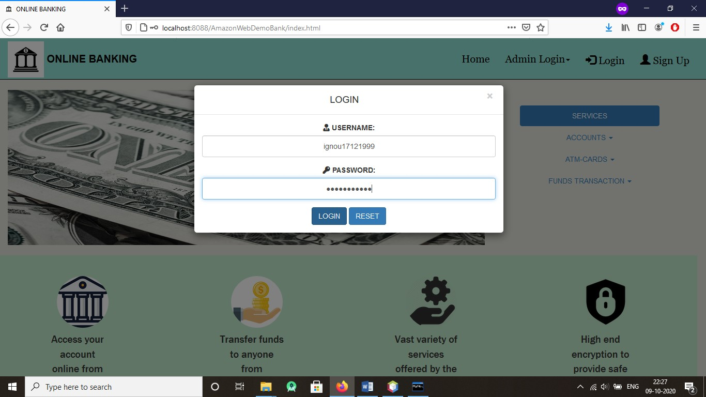

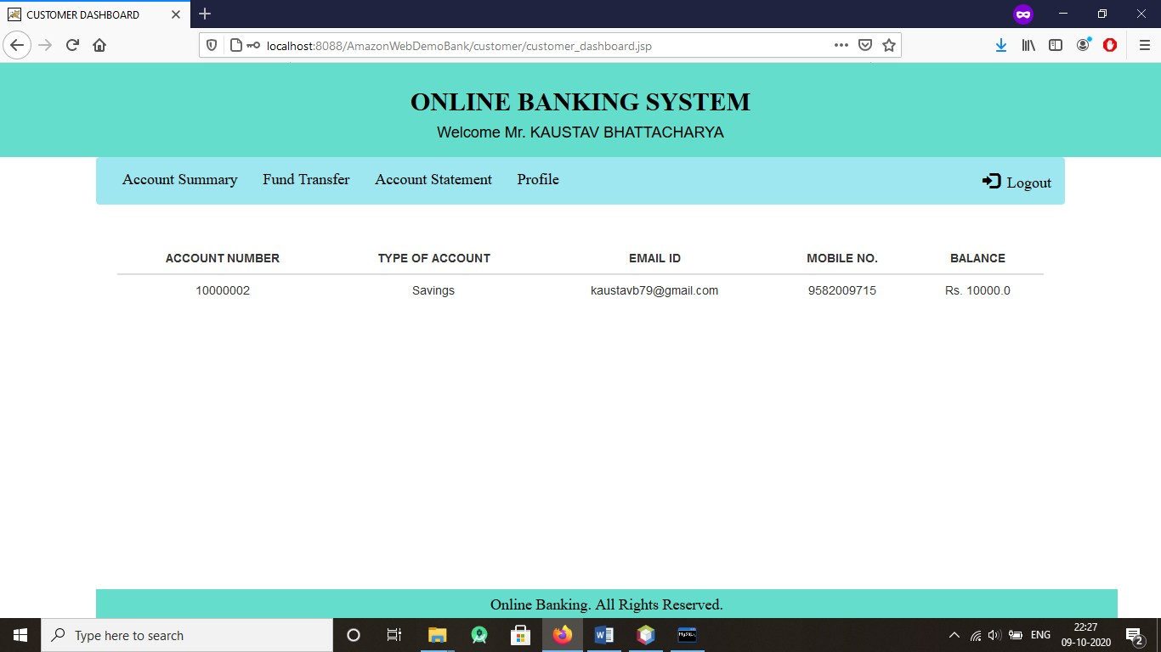

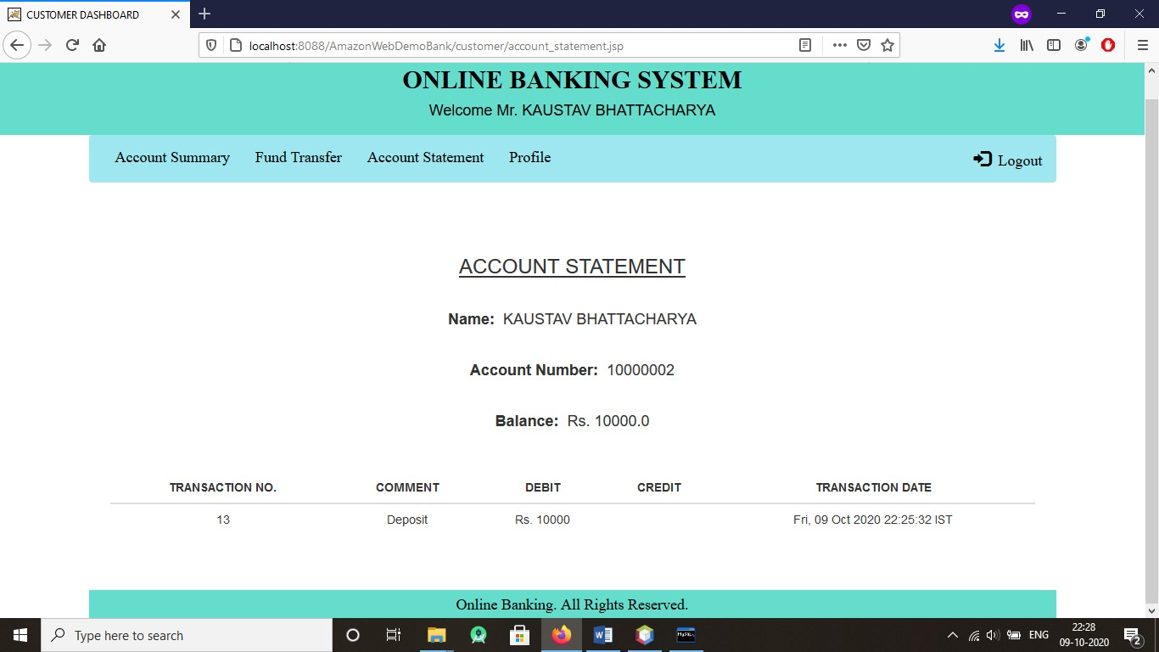

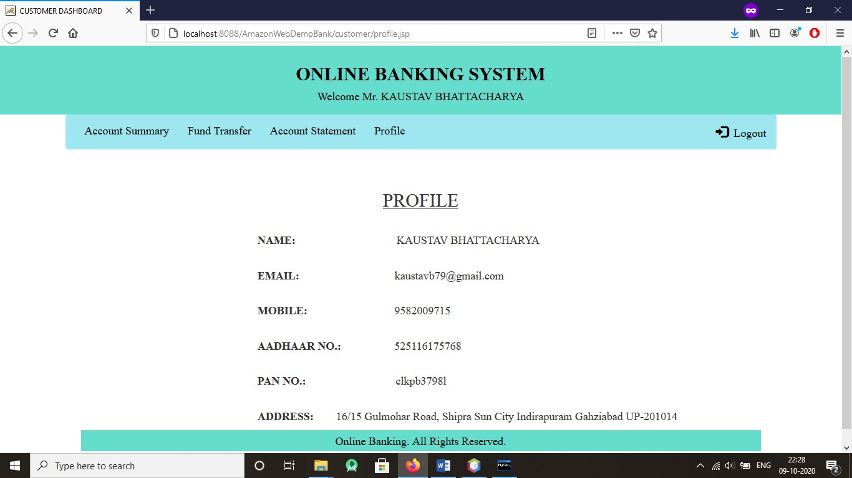

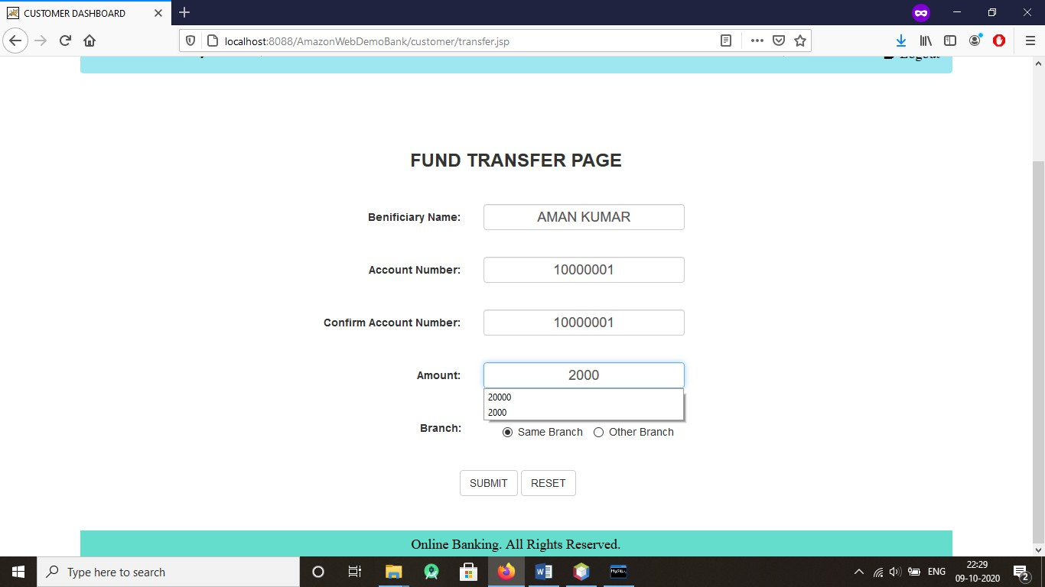

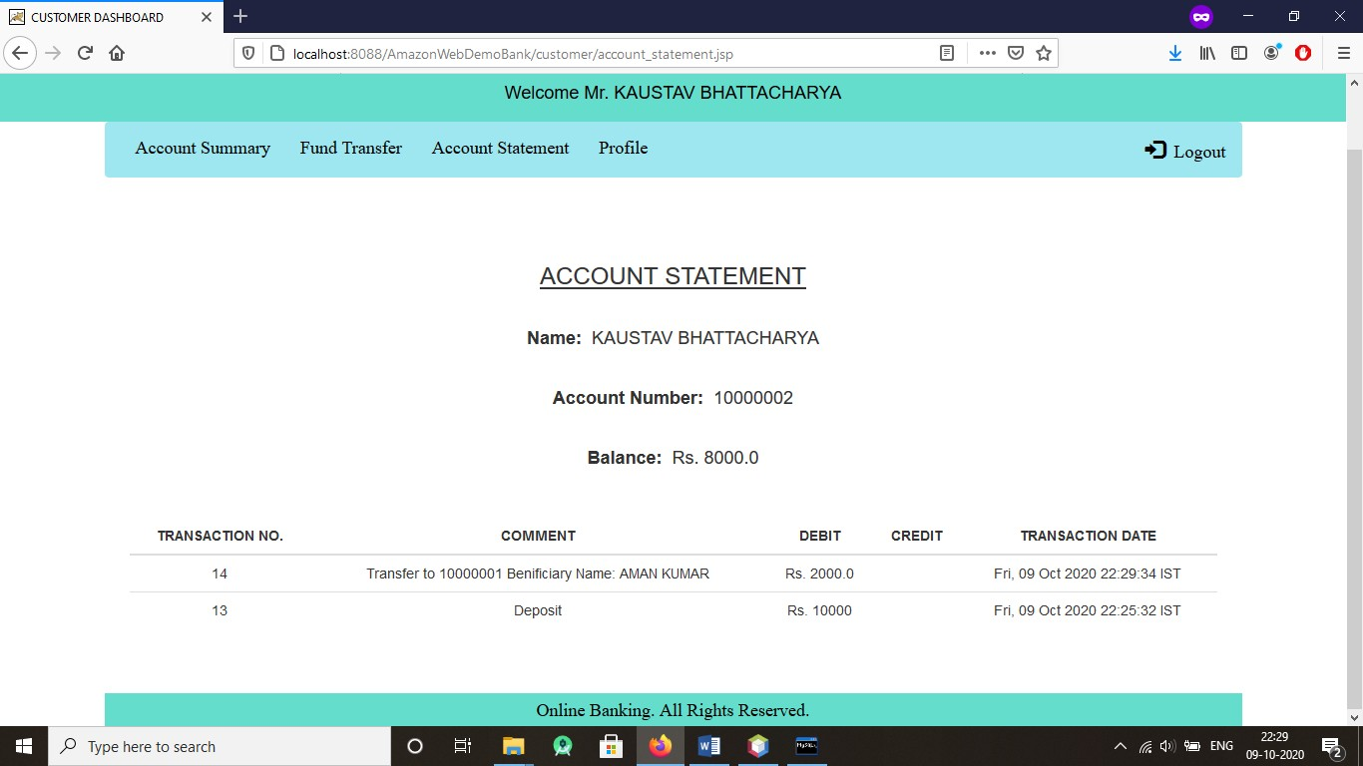

(Transaction No.14)

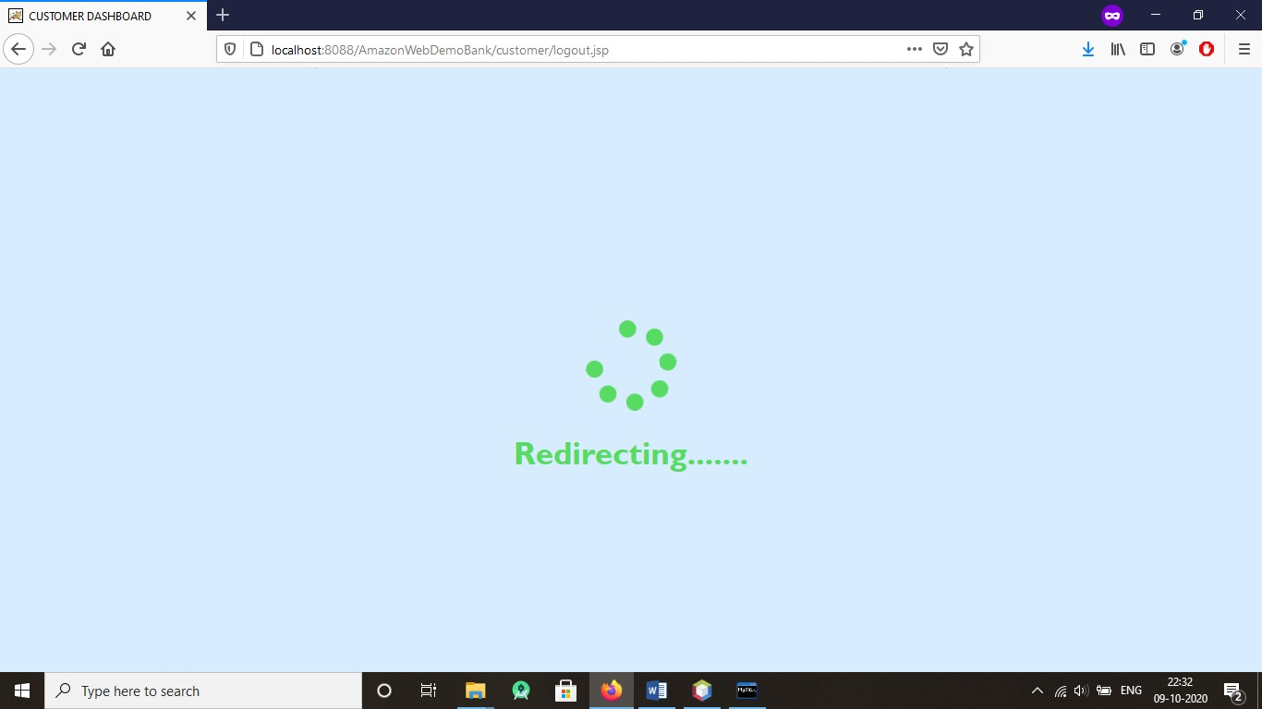

(Logout page)

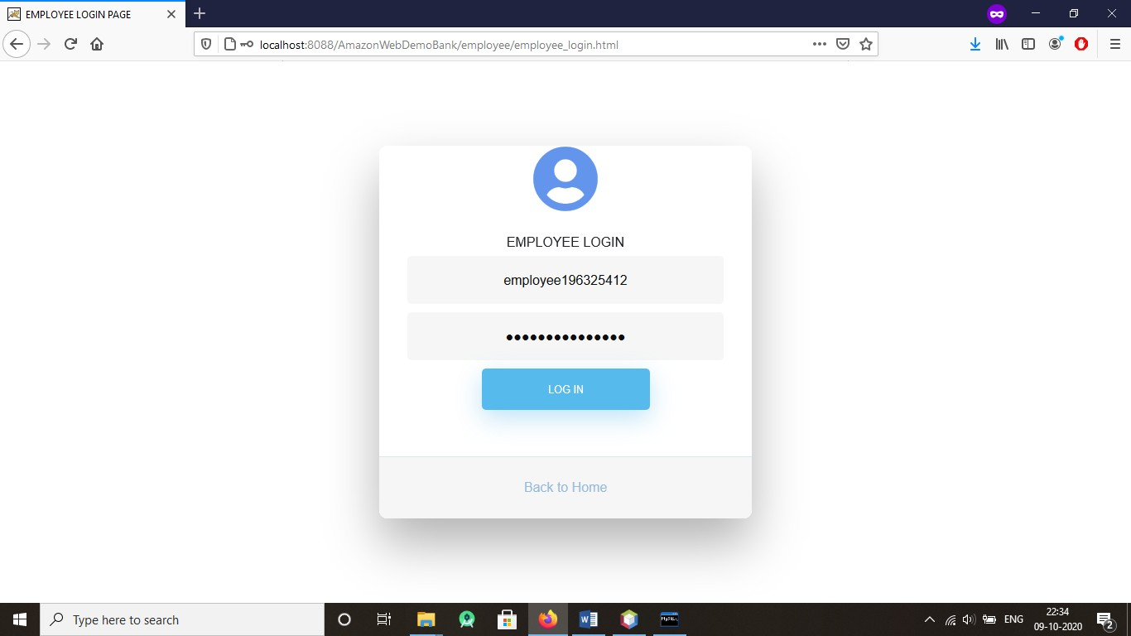

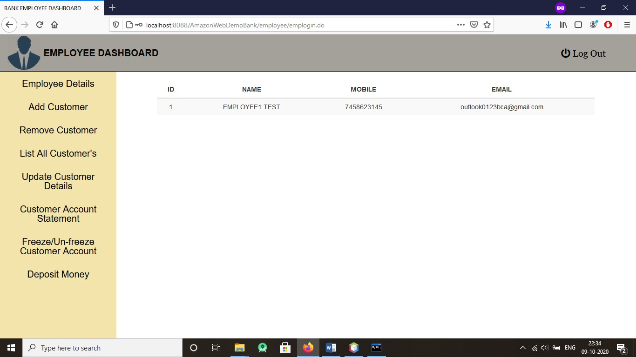

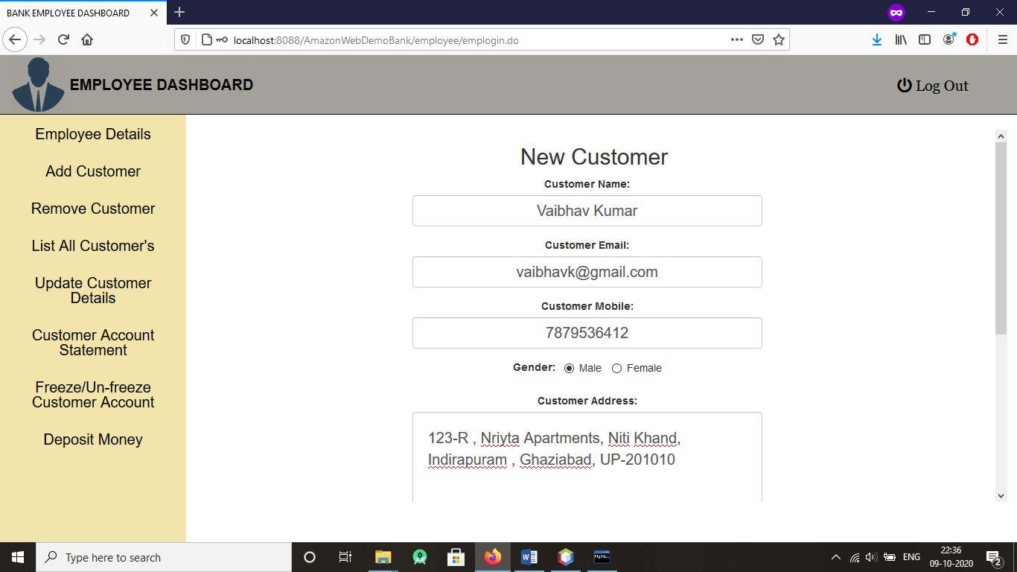

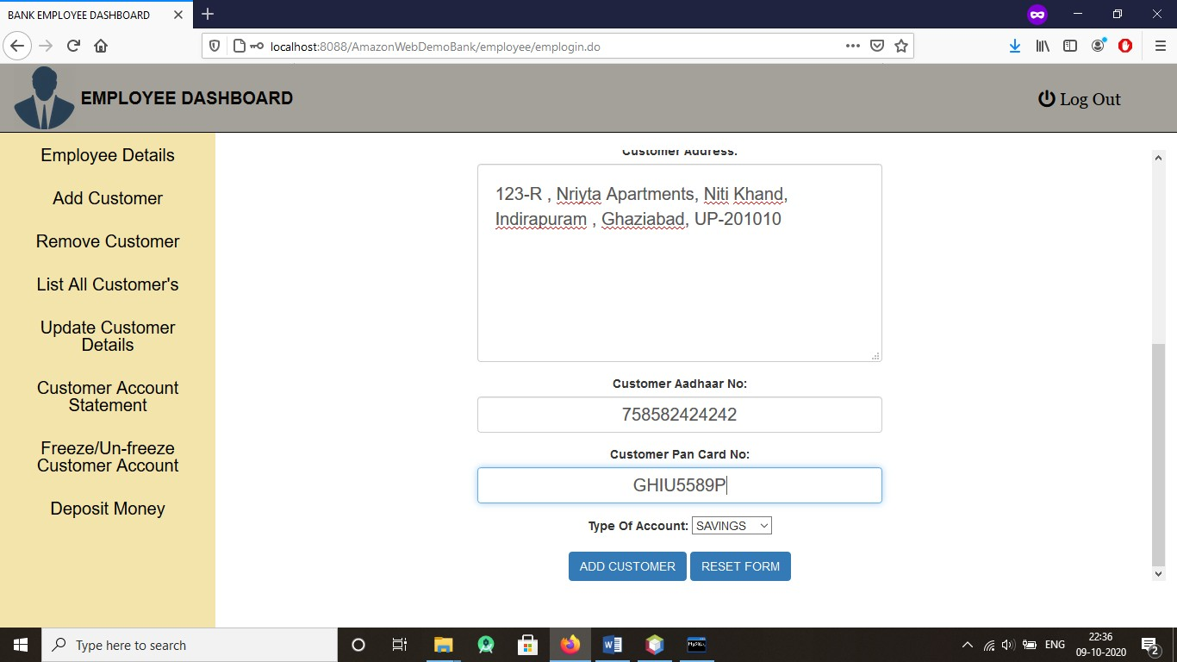

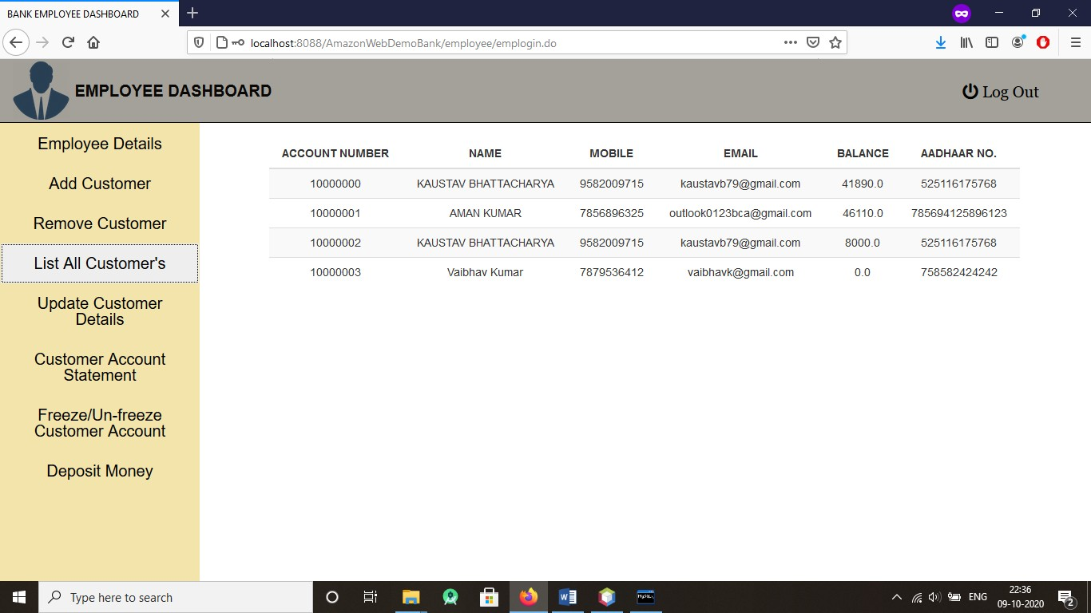

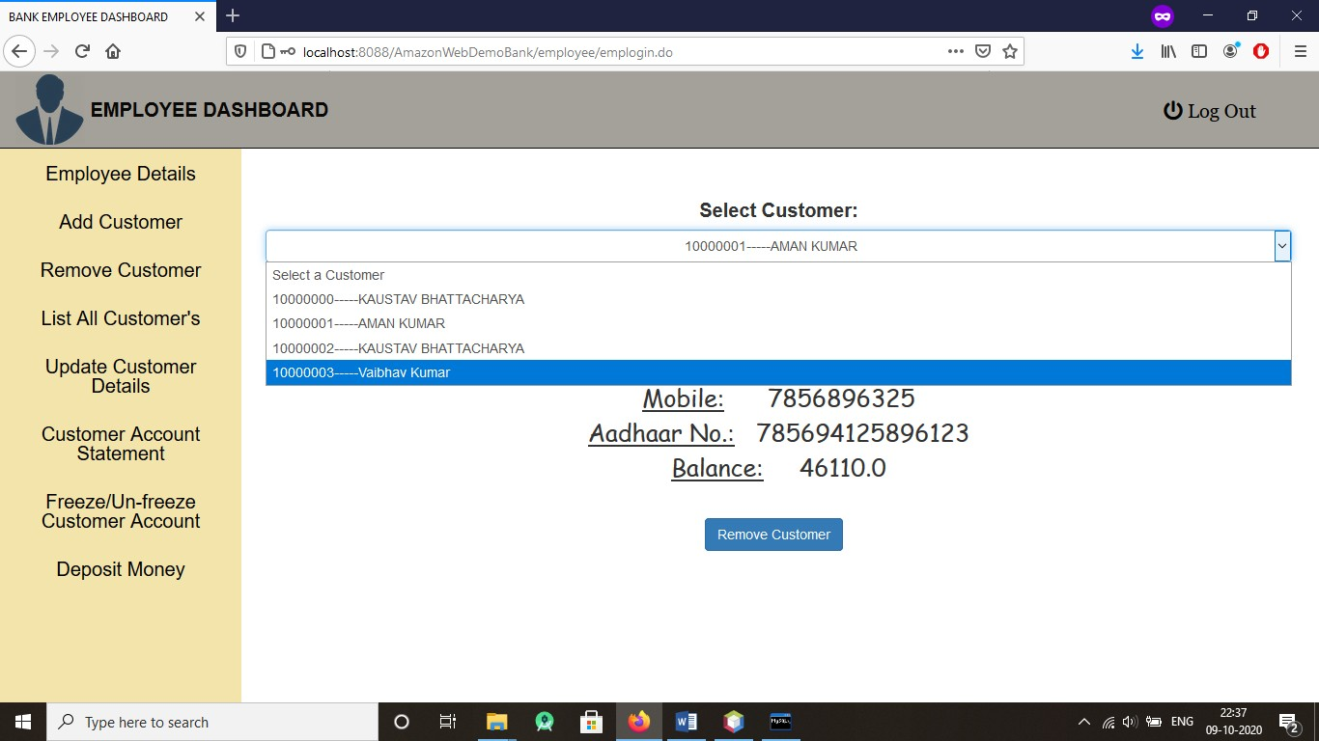

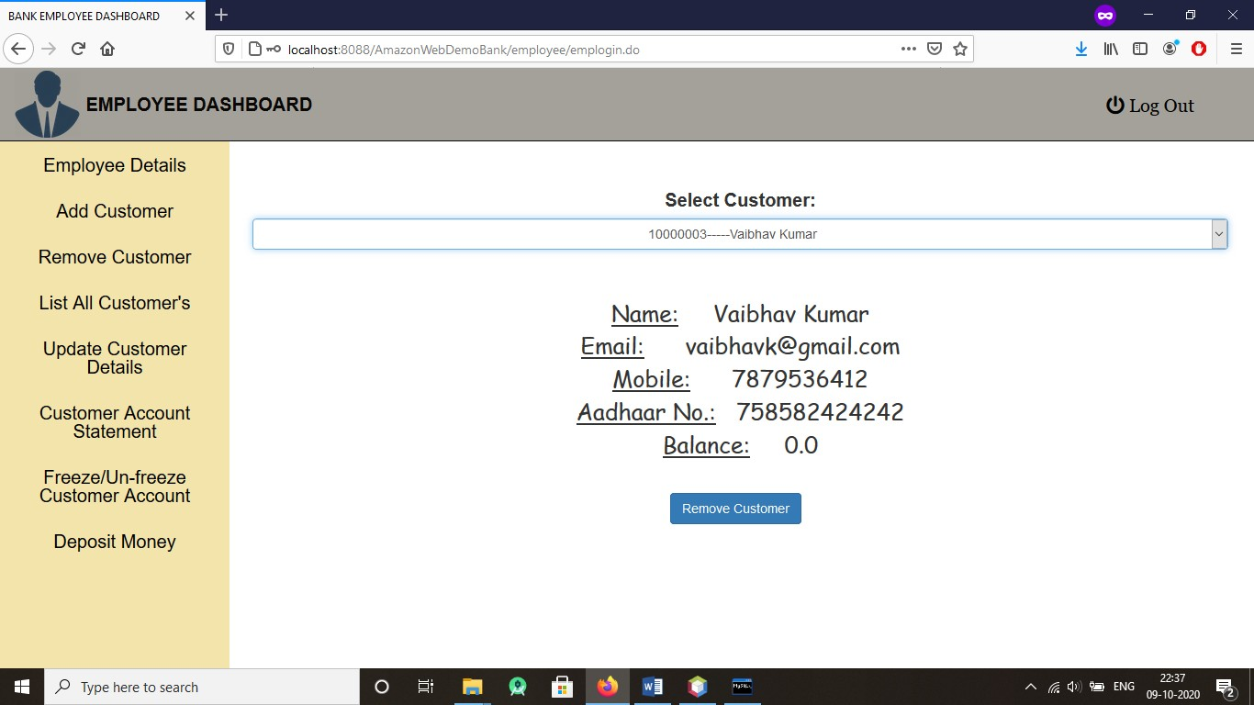

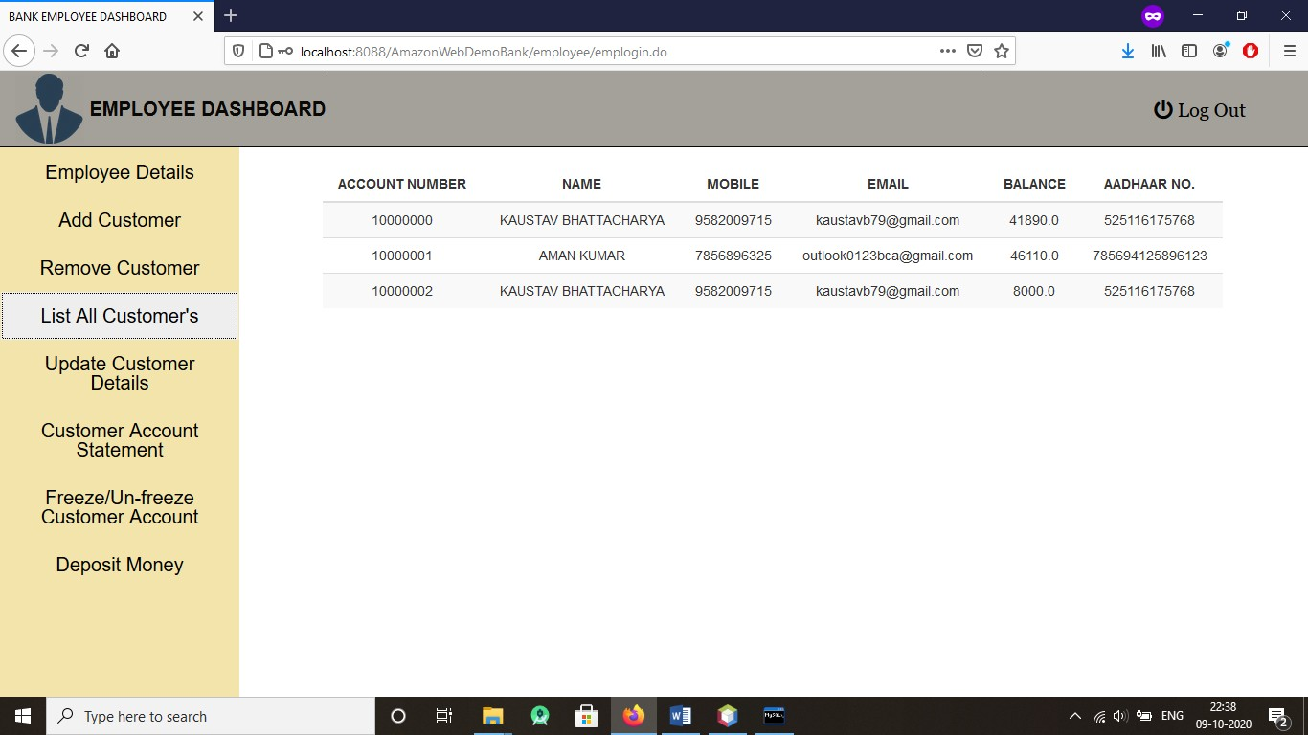

Customer ‘Vaibhav Kumar’ Removed Successfully

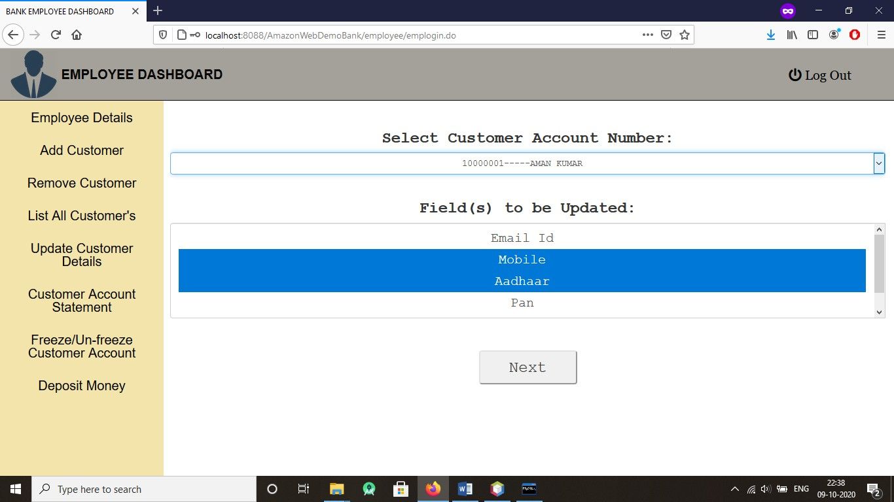

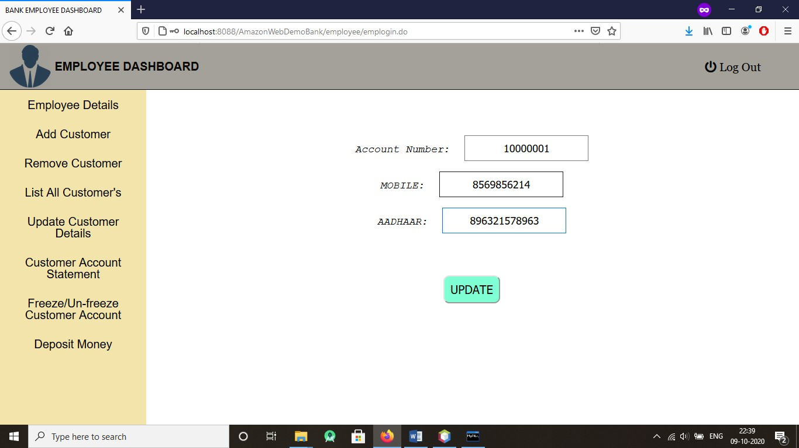

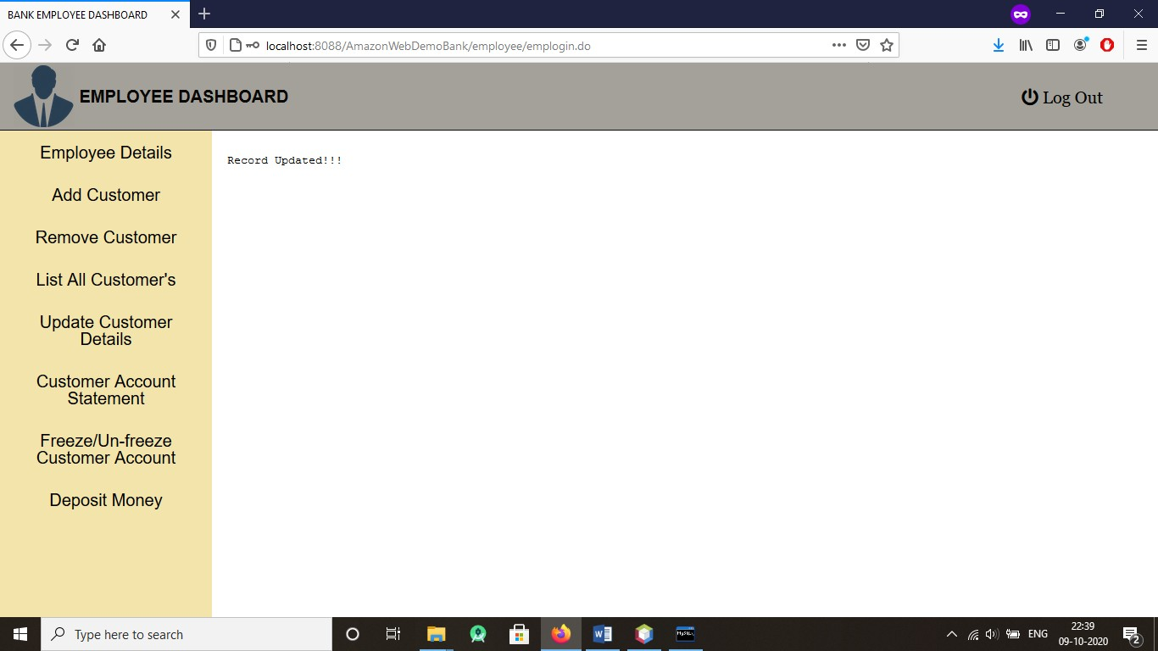

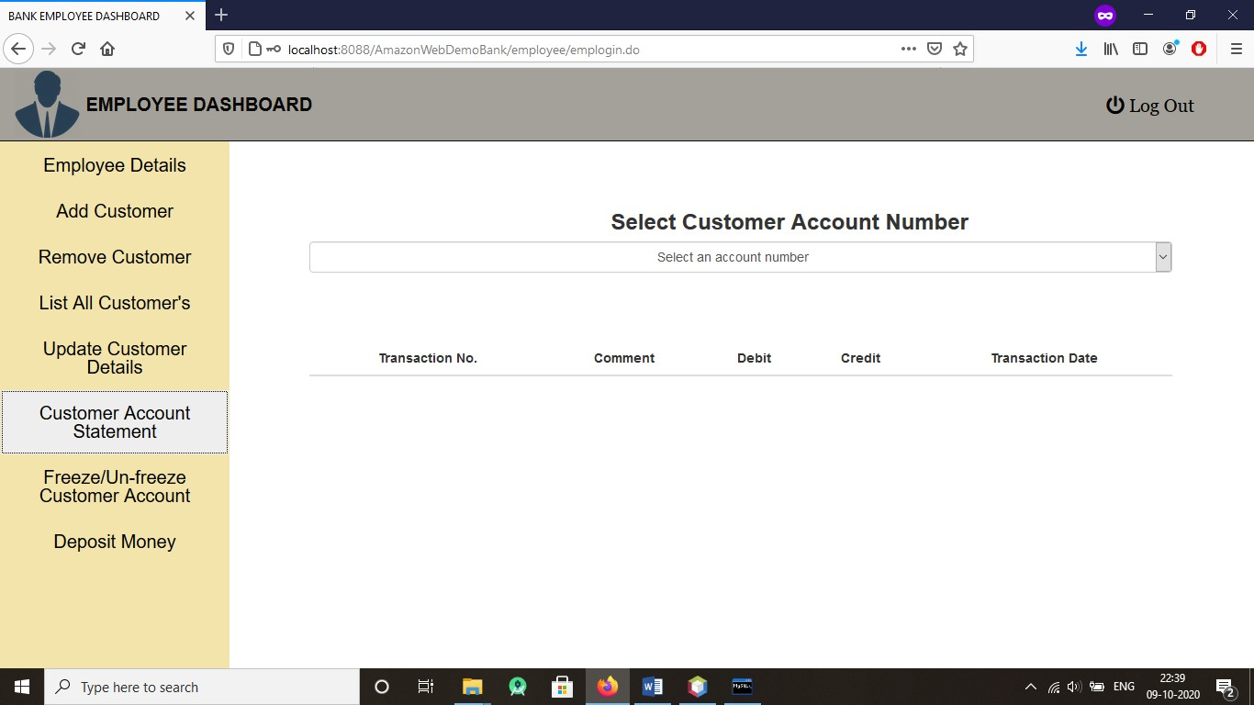

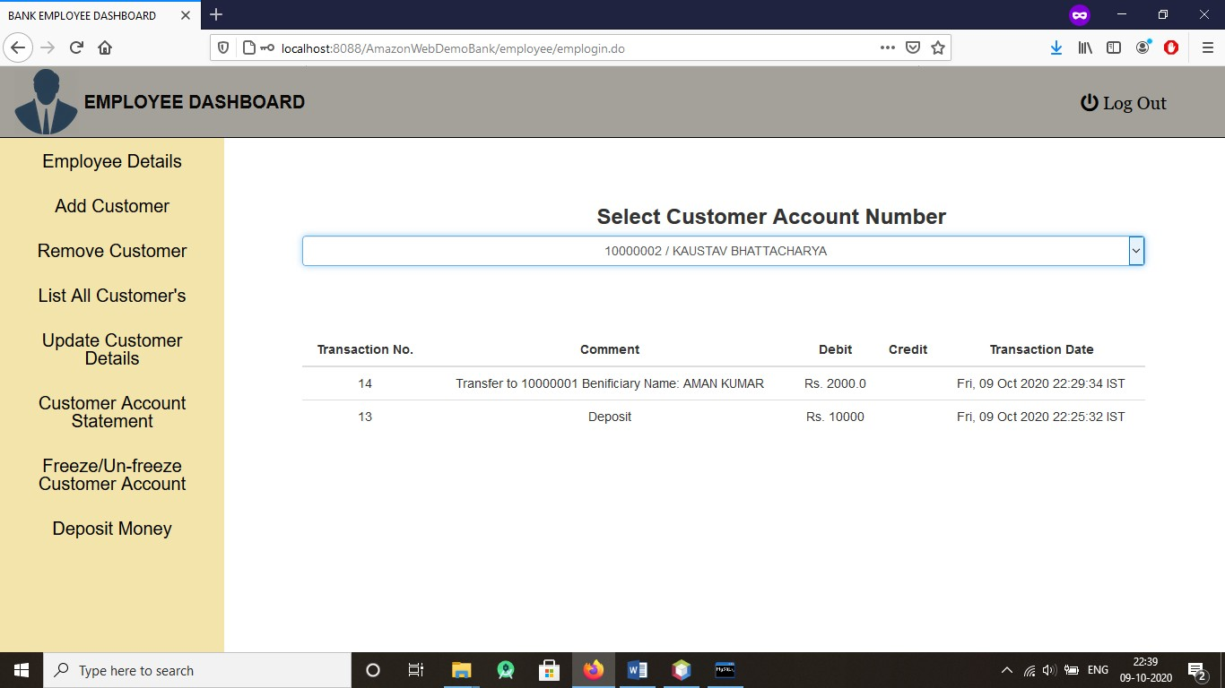

(Records of all past transactions for a/c – 100000002)

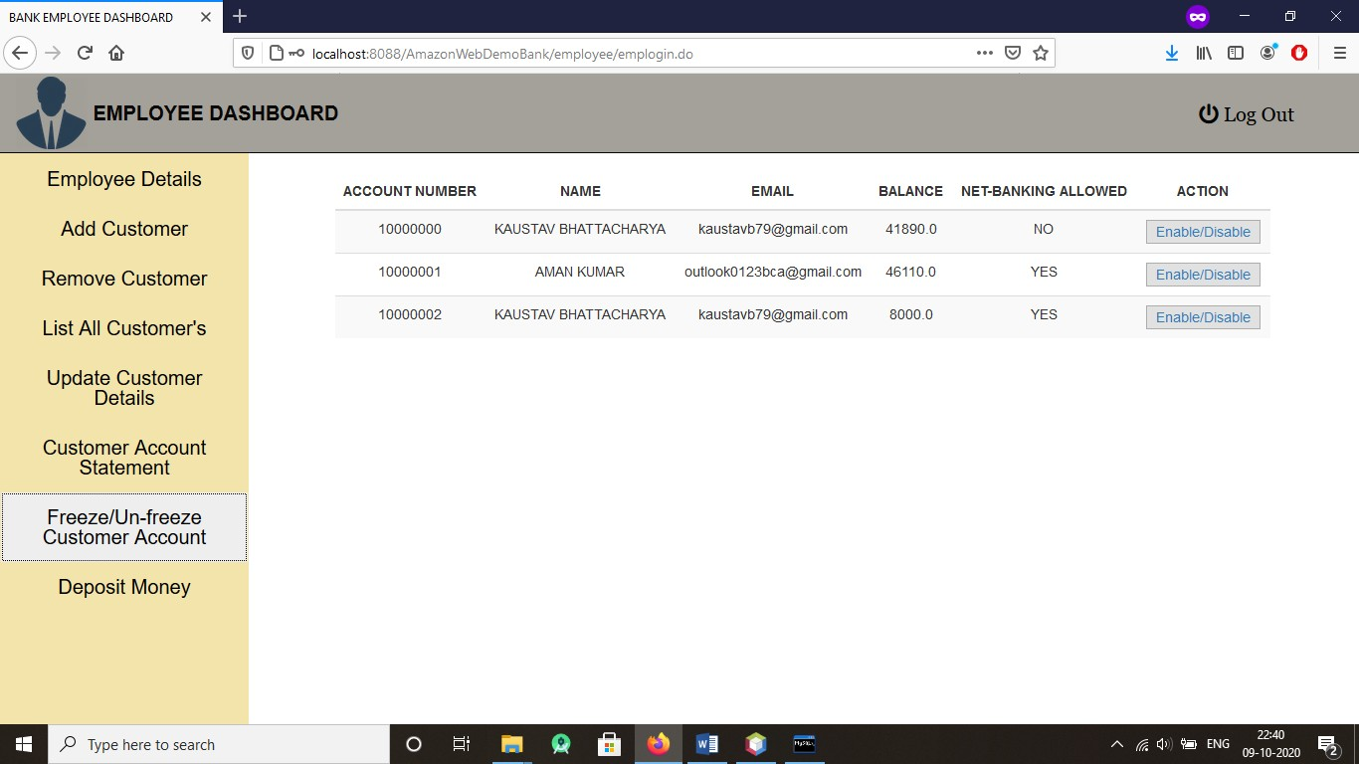

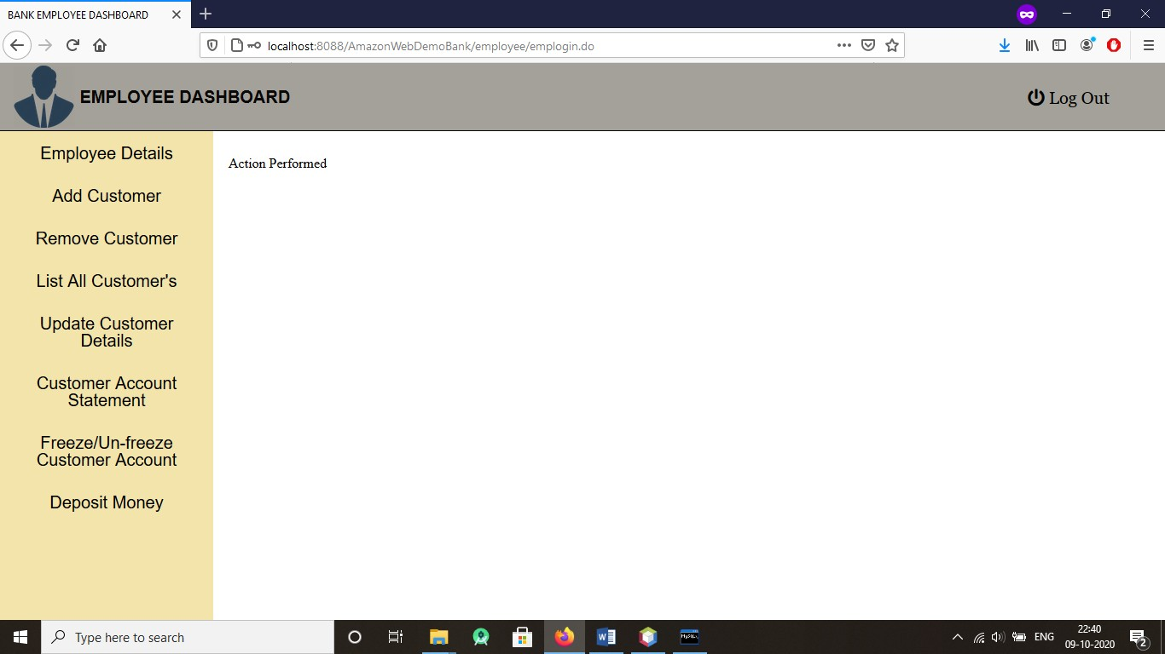

Transaction Services Disabled for account number – 10000002

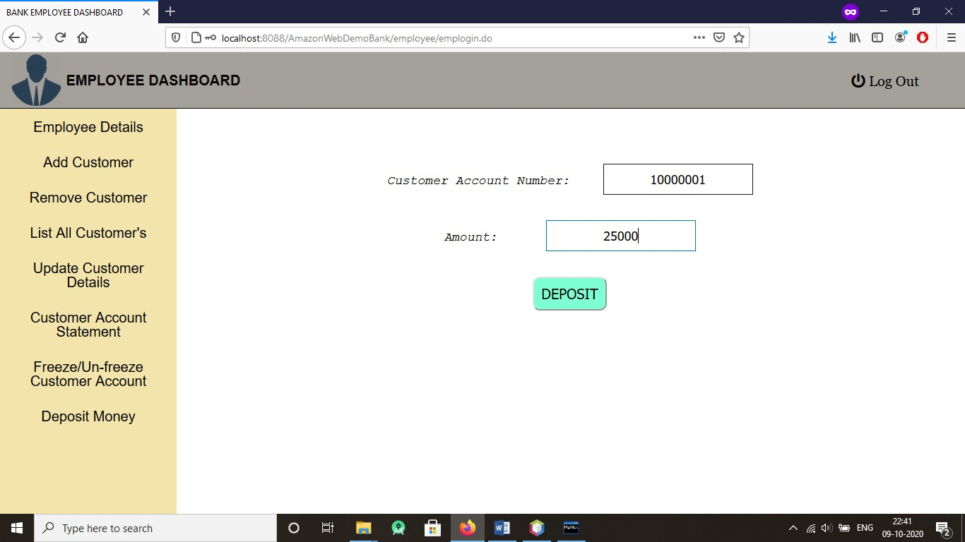

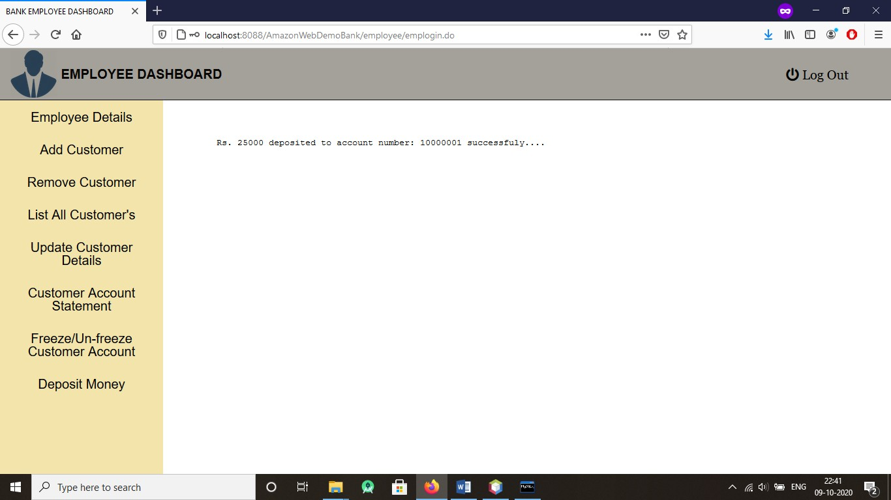

(Amount- Rs. 25000 deposited to account 100000001)

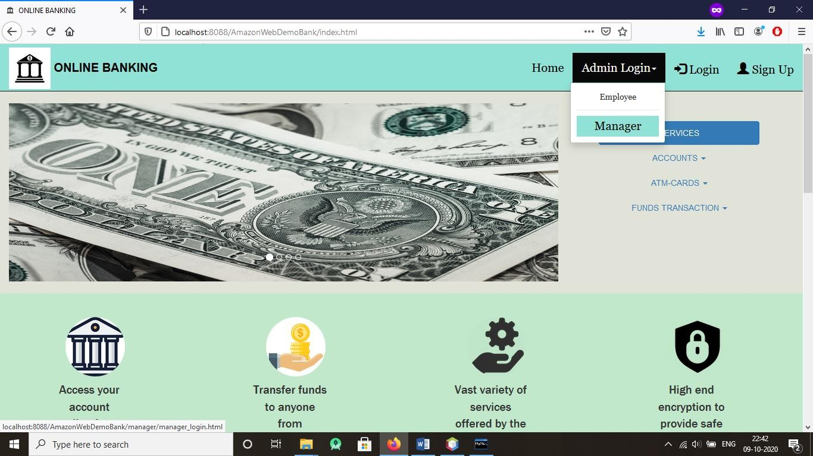

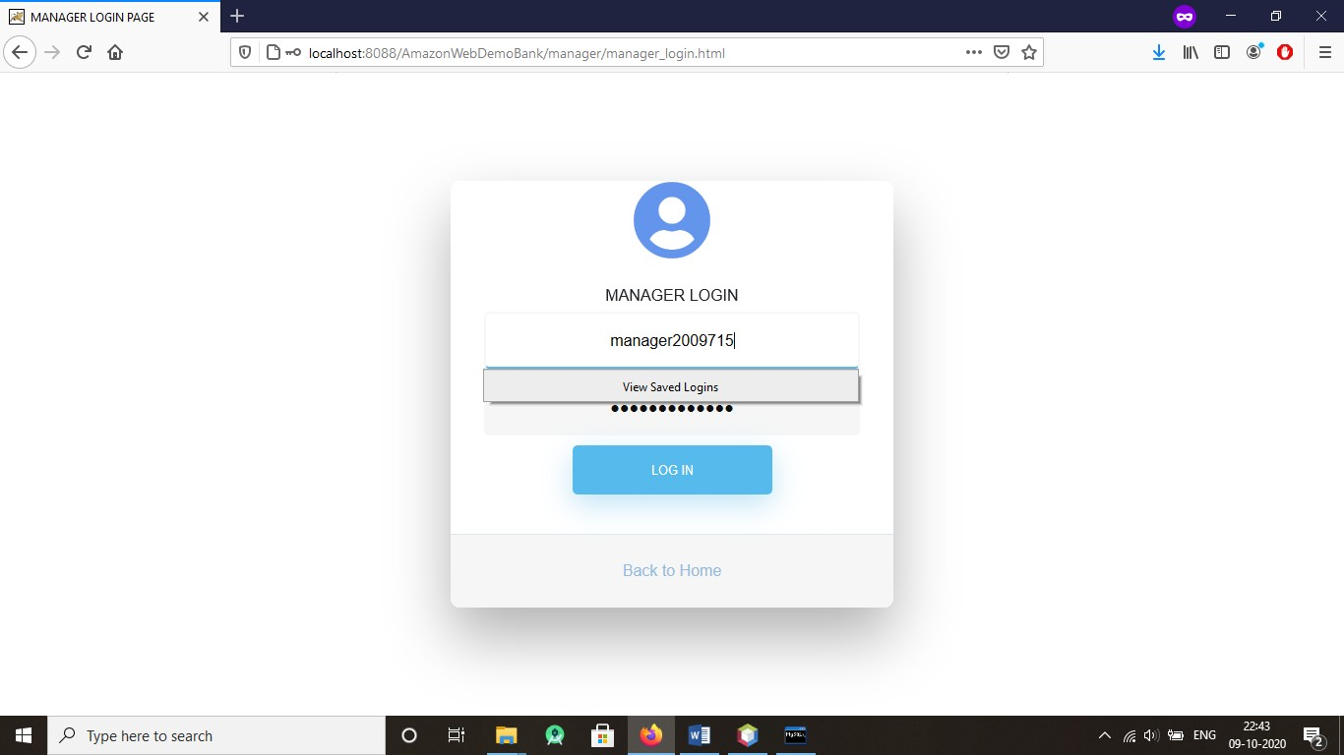

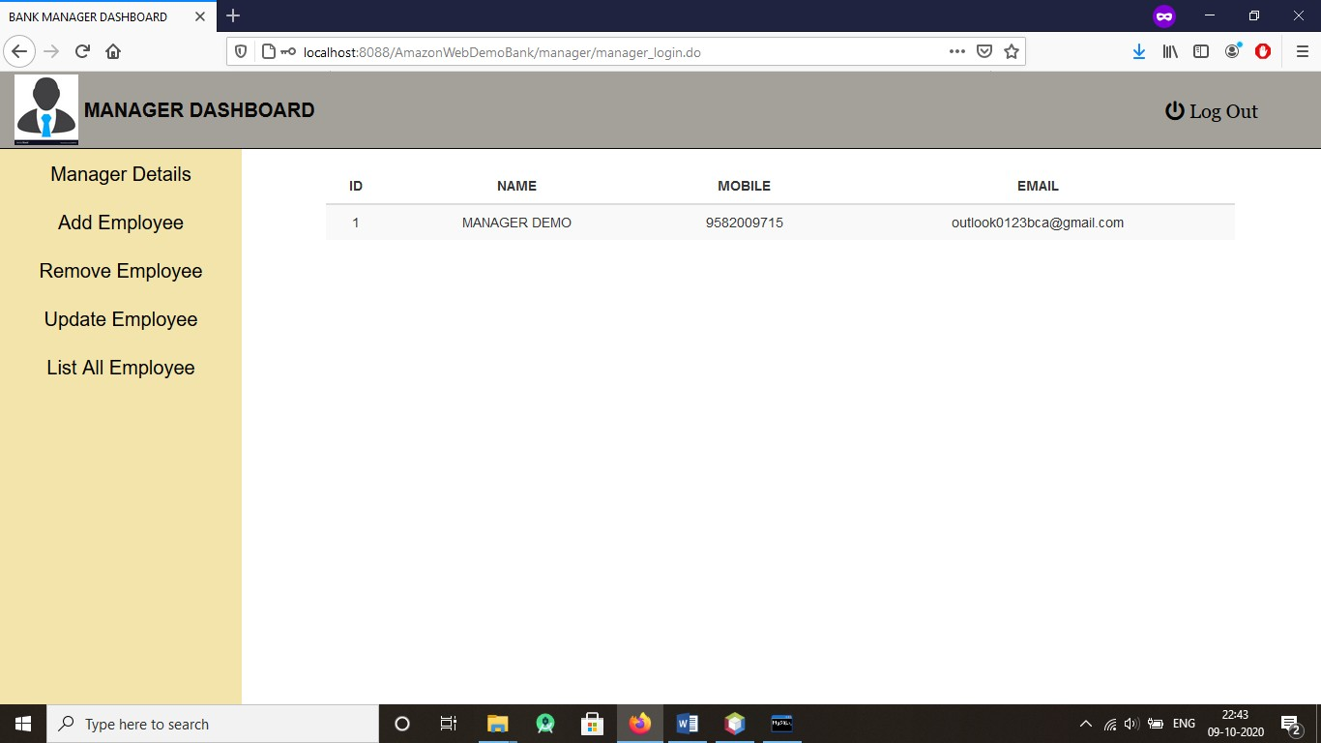

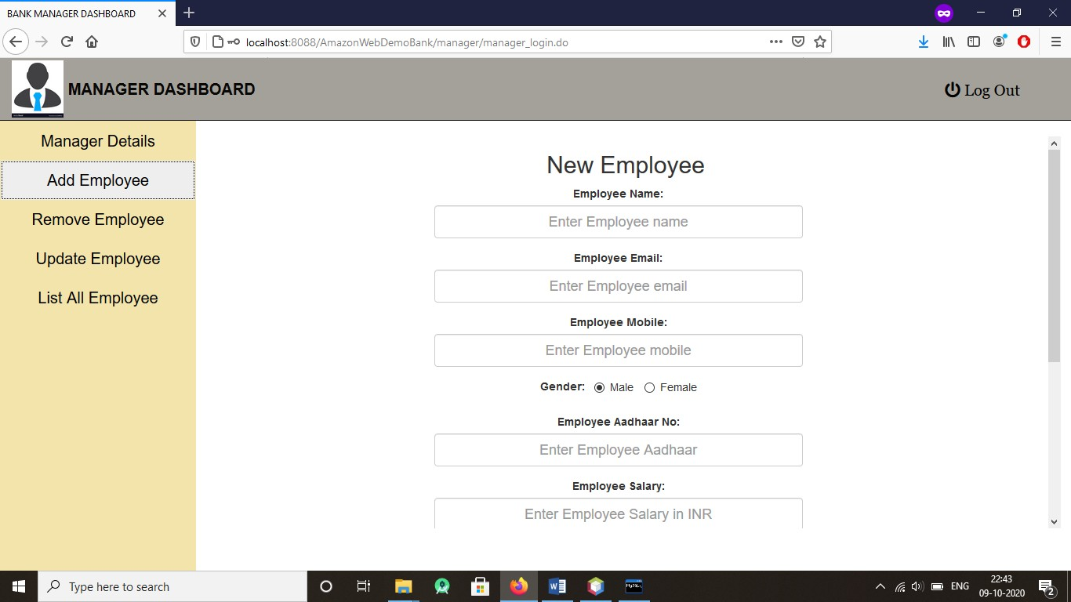

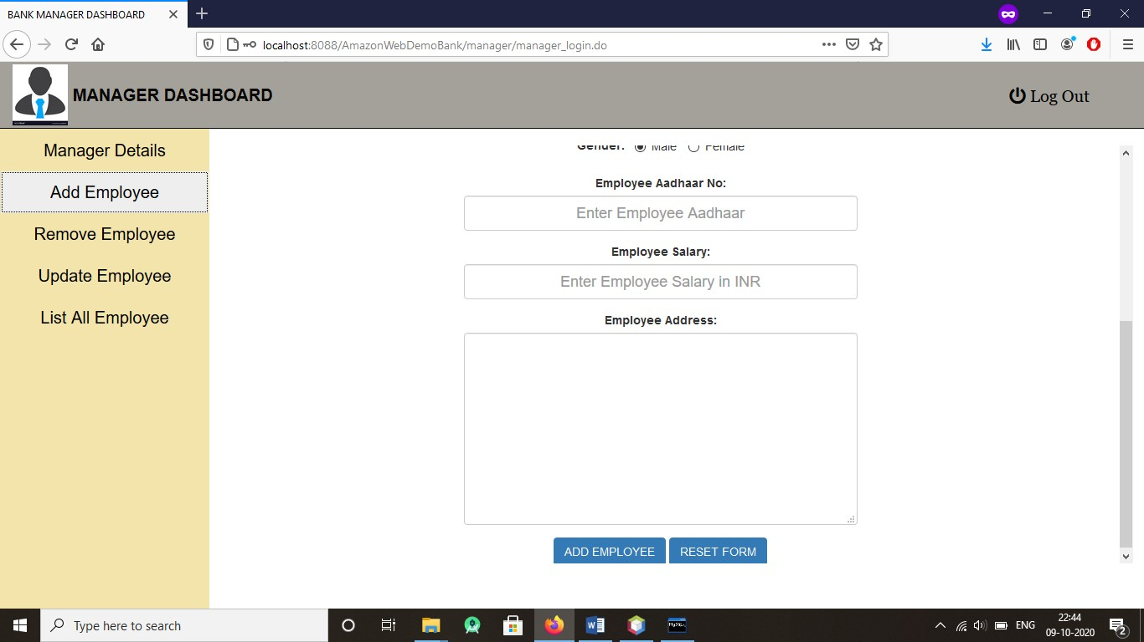

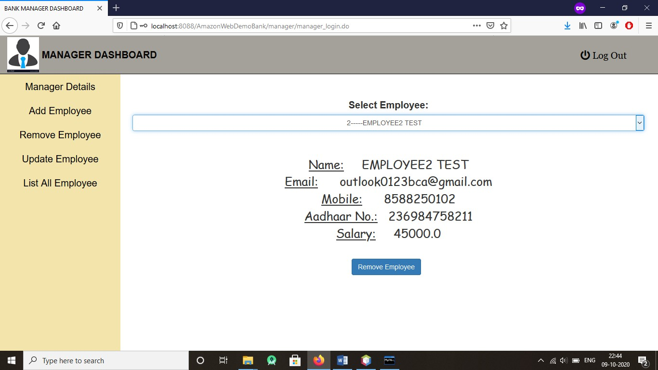

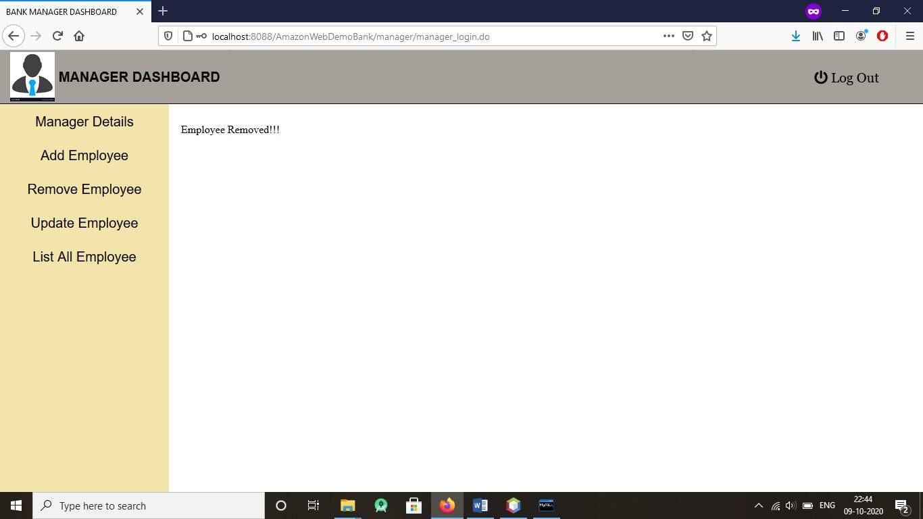

(Employee with id -2 Removed)

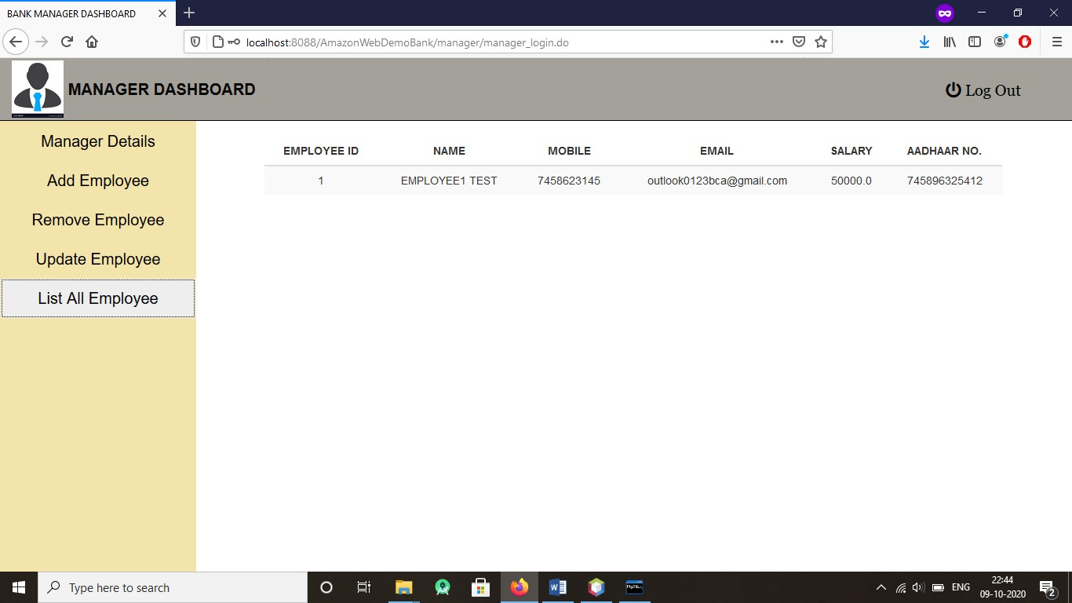

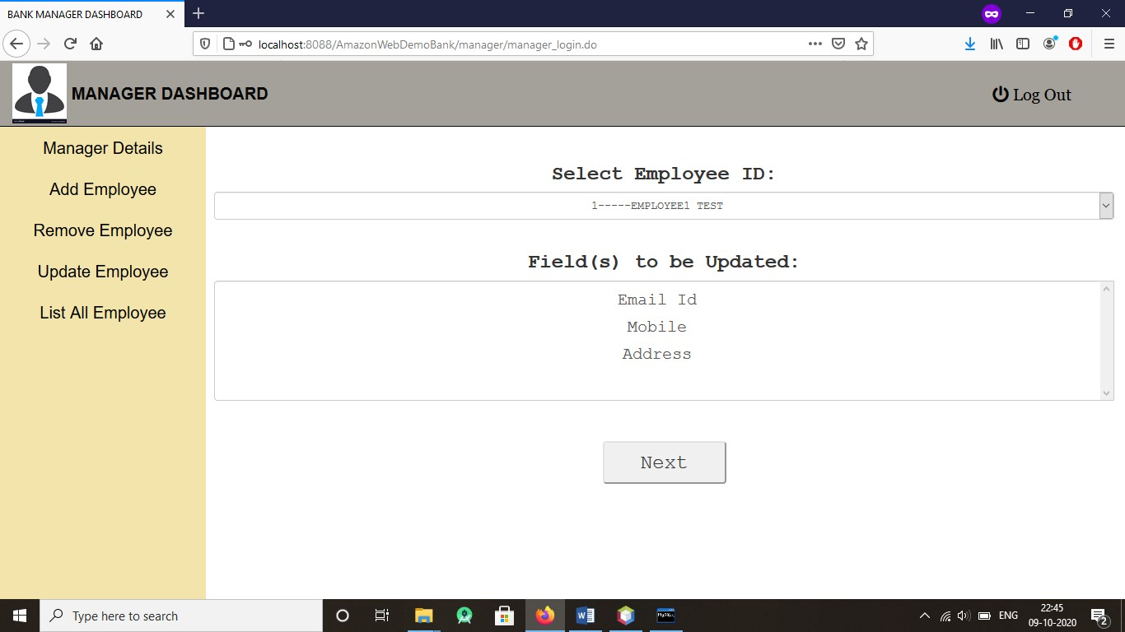

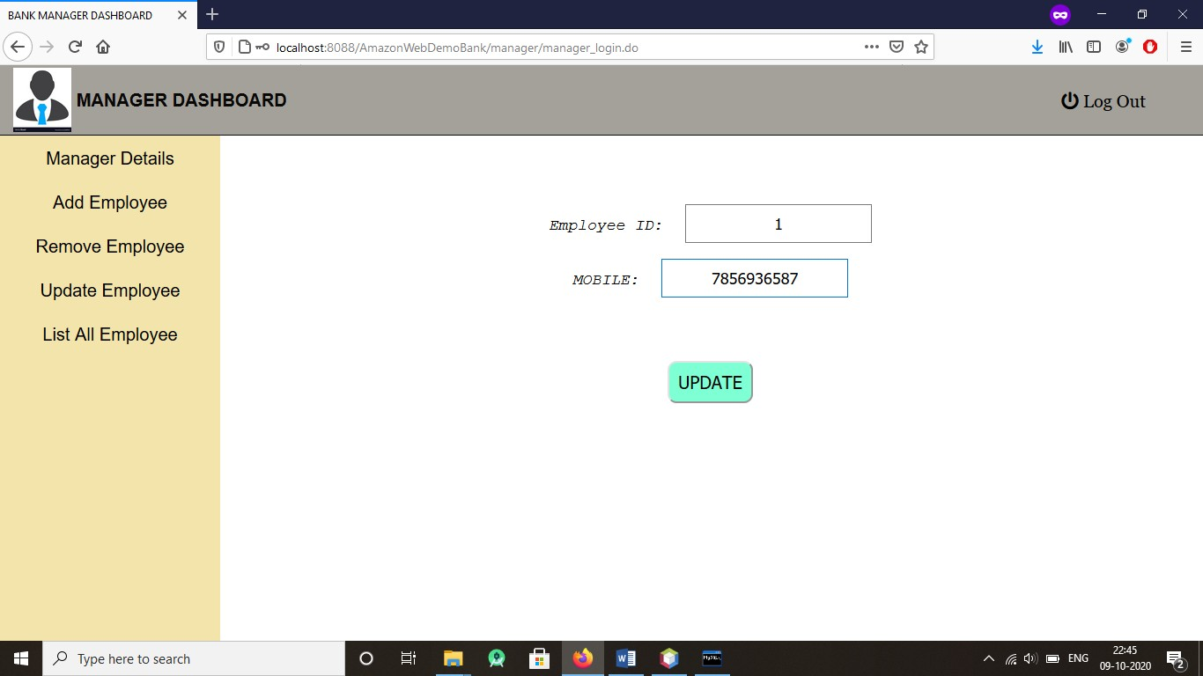

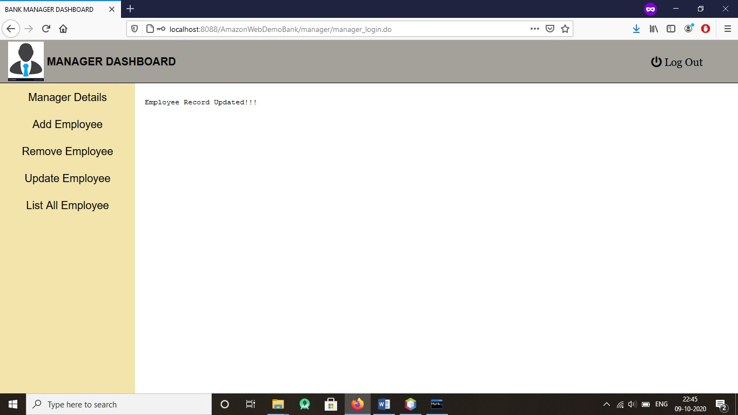

(Mobile no. of employee with id- 1 updated)

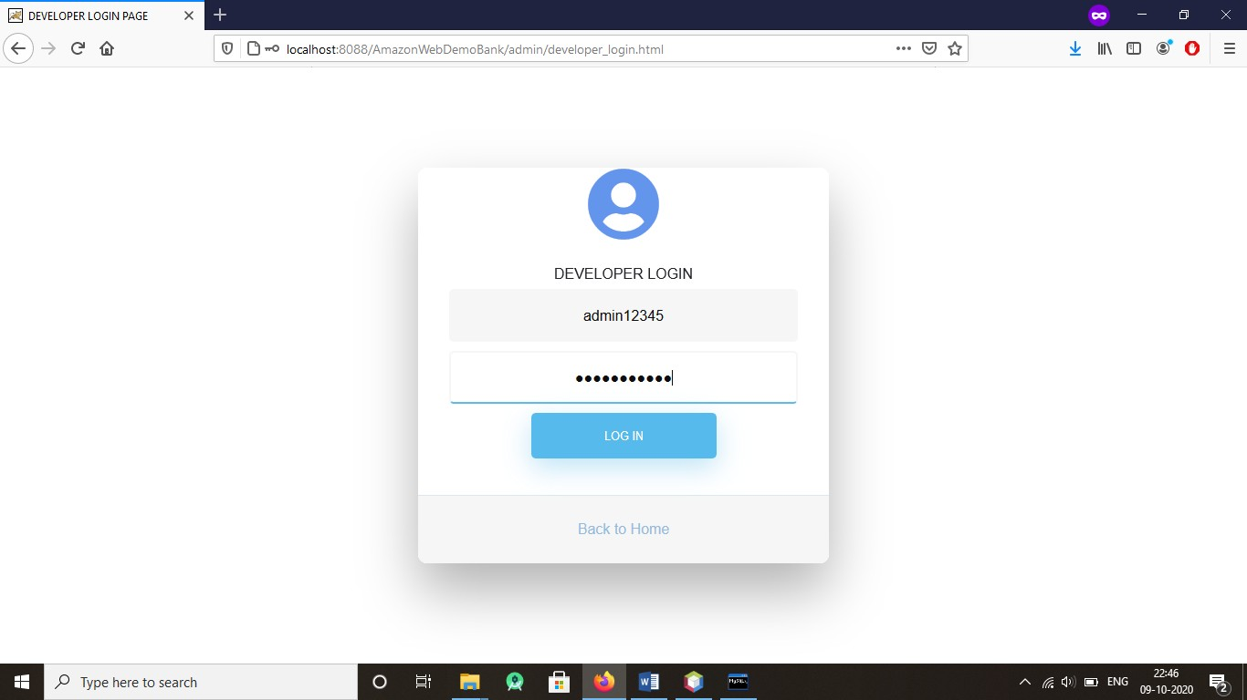

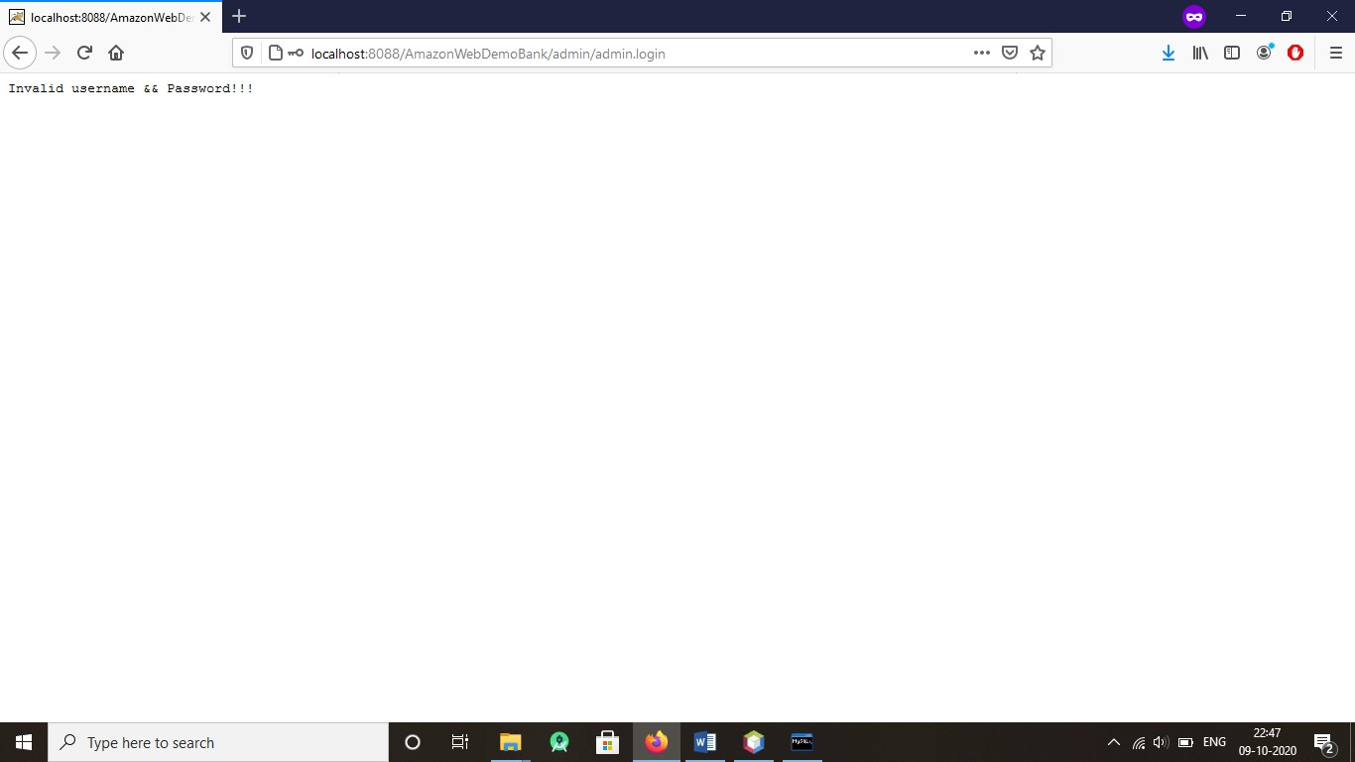Incorrect Details…

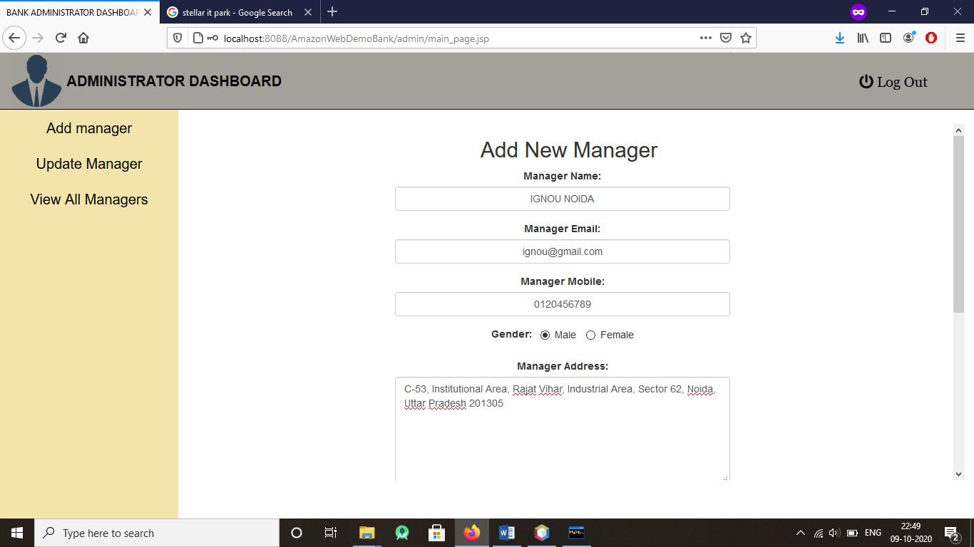

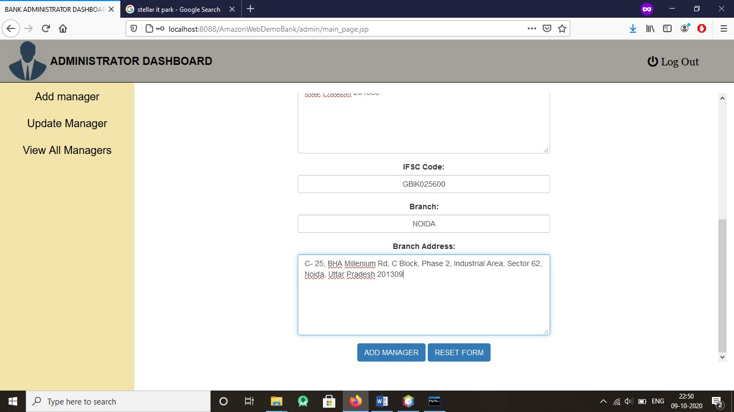

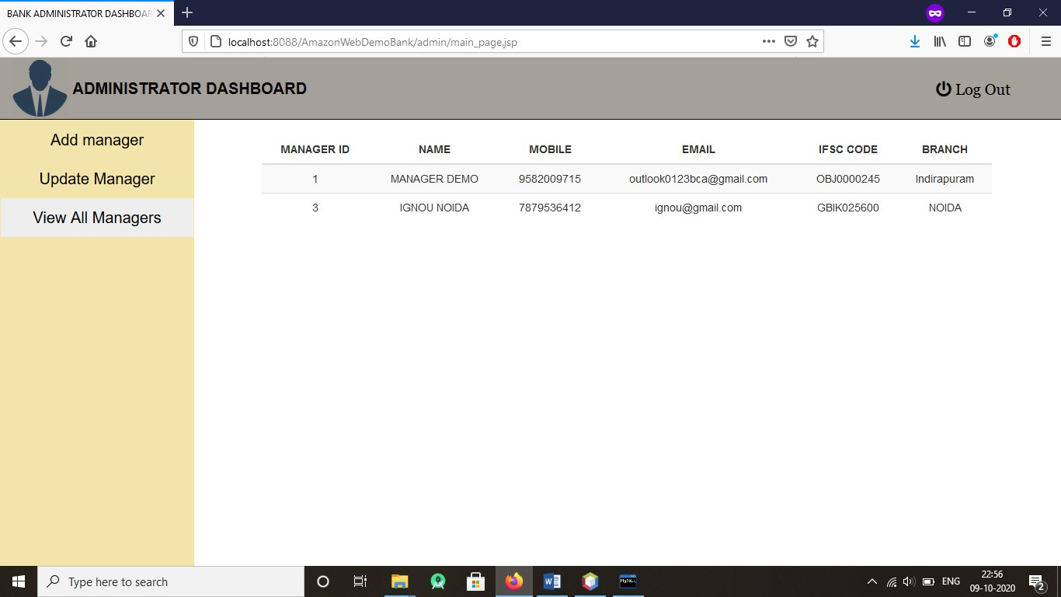

(Manager – ‘IGNOU Noida ‘Added successfully)

# IMPLEMENTATION OF SECURITY

As computers and other digital devices have become essential to business and commerce, they have also increasingly become a target for attacks. In order for a company or an individual to use a computing device with confidence, they must first be assured that the device is not compromised in any way and that all communications will be secure. In this chapter, we will review the fundamental concepts of information System s security and discuss some of the measures that can be taken to mitigate security threats. We will begin with an overview focusing on how organizations can stay secure. Several different measures that a company can take to improve security will be discussed. We will then follow up by reviewing security precautions that individuals can take in order to secure their personal computing environment.

**The Information Security Triad: Confidentiality, Integrity, Availability (CIA)**

* **Confidentiality**

When protecting information, we want to be able to restrict access to those who are allowed to see it; everyone else should be disallowed from learning anything about its contents. This is the essence of confidentiality. For example, federal law requires that universities restrict access to private student information. The university must be sure that only those who are authorized have access to view the grade records.

### Integrity

Integrity is the assurance that the information being accessed has not been altered and truly represents what is intended. Just as a person with integrity means what he or she says and can be trusted to consistently represent the truth, information integrity means information truly represents its intended meaning. Information can lose its integrity through malicious intent, such as when someone who is not authorized makes a change to intentionally misrepresent something. An example of this would be when a hacker is hired to go into the university’s System and change a grade.

Integrity can also be lost unintentionally, such as when a computer power surge corrupts a file or someone authorized to make a change accidentally deletes a file or enters incorrect information.

### Availability

Information availability is the third part of the CIA triad. Availability means that information can be accessed and modified by anyone authorized to do so in an appropriate timeframe. Depending on the type of information, appropriate timeframe can mean different things. For example, a stock trader needs information to be available immediately, while a sales person may be happy to get sales numbers for the day in a report the next morning.

Companies such as Amazon.com will require their servers to be available twenty-four hours a day, seven days a week. Other companies may not suffer if their web servers are down for a few minutes once in a while.

### Tools for Information Security

In order to ensure the confidentiality, integrity, and availability of information, organizations can choose from a variety of tools. Each of these tools can be utilized as part of an overall information-security policy, which will be discussed in the next section.

### Authentication

The most common way to identify someone is through their physical appearance, but how do we identify someone sitting behind a computer screen or at the ATM? Tools for authentication are used to ensure that the person accessing the information is, indeed, who they present themselves to be.

Authentication can be accomplished by identifying someone through one or more of three factors: something they know, something they have, or something they are. For example, the most common form of authentication today is the user ID and password. In this case, the authentication is done by confirming something that the user knows (their ID and password). But this form of authentication is easy to compromise (see sidebar) and stronger forms of authentication are sometimes needed. Identifying someone only by something they have, such as a key or a card, can also be problematic. When that identifying token is lost or stolen, the identity can be easily stolen. The final factor, something you are, is much harder to compromise. This factor identifies a user through the use of a physical characteristic, such as an eye-

scan or fingerprint. Identifying someone through their physical characteristics is called biometrics.

A more secure way to authenticate a user is to do multi-factor authentication. By combining two or more of the factors listed above, it becomes much more difficult for someone to misrepresent themselves.

### Access Control

Once a user has been authenticated, the next step is to ensure that they can only access the information resources that are appropriate. This is done through the use of access control. Access control determines which users are authorized to read, modify, add, and/or delete information. Several different access control models exist. Here we will discuss two: the access control list (ACL) and role-based access control (RBAC).

For each information resource that an organization wishes to manage, a list of users who have the ability to take specific actions can be created. This is an access control list, or ACL. For each user, specific capabilities are assigned, such as read, write, delete, or add. Only users with those capabilities are allowed to perform those functions. If a user is not on the list, they have no ability to even know that the information resource exists.

ACLs are simple to understand and maintain. However, they have several drawbacks. The primary drawback is that each information resource is managed separately, so if a security administrator wanted to add or remove a user to a large set of information resources, it would be quite difficult. And as the number of users and resources increase, ACLs become harder to maintain. This has led to an improved method of access control, called role- based access control, or RBAC. With RBAC, instead of giving specific users access rights to an information resource, users are assigned to roles and then those roles are assigned the access. This allows the administrators to manage users and roles separately, simplifying administration and, by extension, improving security.

### Encryption

Many times, an organization needs to transmit information over the Internet or transfer it on external media such as a CD or flash drive. In these cases, even with proper authentication and access control, it is possible for an unauthorized person to get access to the data. Encryption is a process of encoding data upon its transmission or storage so that only authorized individuals can read it. This encoding is accomplished by a computer program, which encodes the plain text that needs to be transmitted; then the recipient receives the cipher text and decodes it (decryption). In order for this to work, the sender and receiver need to agree on the method of encoding so that both parties can communicate properly. Both parties share the encryption key, enabling them to encode and decode each other’s messages. This is called symmetric key encryption. This type of encryption is problematic because the key is available in two different places.

An alternative to symmetric key encryption is public key encryption. In public key encryption, two keys are used: a public key and a private key. To send an encrypted message, you obtain the public key, encode the message, and send it. The recipient then uses the private key to decode it. The public key can be given to anyone who wishes to send the recipient a message.

Each user simply needs one private key and one public key in order to secure messages. The private key is necessary in order to decrypt something sent with the public key.

# LIMITATIONS OF PROJECT

### Documentation:

It is time consuming and requires expertise in creating good documentation from view point of top admin users.

### Manuals:

Various manuals are to be prepared such as user manuals, System manuals etc. It needs time, human labor and are subject to change drastically as the technology changes.

### Online Help:

One needs to provide online help to various users so that all the features of the software can be properly understood by the user.

### Complexity:

It is time consuming to manage and debug all the modules one by one.

# FUTURE APPLICATION OF THE PROJECT

* Linking and integration of any legacy system for accounting.
* Integration with other bank and government agencies through Web Services
* Connection to third-party OLAP applications
* Electronic Data Interchange (EDI) system for ATM machine
* Addition of other financial services like loan management, Fixed Deposit.
* In the area of data security and system security.
* Provide more online tips and help.
* Check Book Issuing service.

# BIBLIOGRAPHY

### Websites

* + [http://www.google.com](http://www.google.com/)
  + [http://www.codeproject.com](http://www.codeproject.com/)
  + [http://www.w3schools.com](http://www.w3schools.com/)
  + [http://www.sqltuner.com](http://www.sqltuner.com/)
  + <https://getbootstrap.com/>
  + <https://www.javatpoint.com/>
  + https://en.wikipedia.org/wiki/Systems_design

### Books

* + Head First (JAVA)
  + HTML & CSS: Design and Build Web Sites
  + Head First SQL: Your Brain on SQ
  + SQL Bible, 2nd Edition (Paperback)
  + System Analysis, Design, and Development: Concepts, Principles, and Practices, Textbook by Charles S. Wasson
  + Java Servlet & JSP Cookbook: Practical Solutions to Real World Problems, Book by Bruce W. Perry